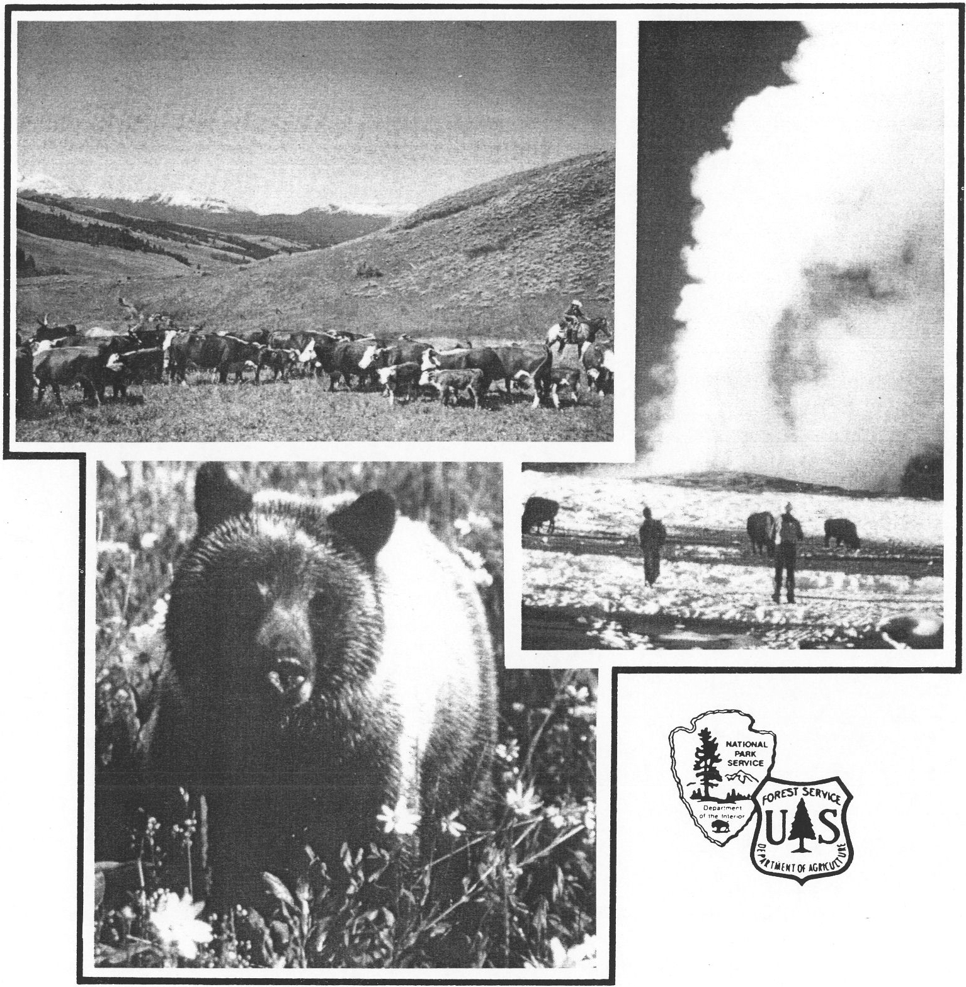

Vision for the Future
A Framework for Coordination
in the Greater Yellowstone Area

DRAFT

FOR MORE INFORMATION

For more information about the management of the Greater Yellowstone Area, please contact any of the following members of the Greater Yellowstone Coordinating Committee:

Team Leader
Greater Yellowstone Coordinating Committee Box 2556
Billings, Montana 59103
Phone: 406-657-6361

Regional Director Rocky Mountain Region National Park Service
P.O. Box 25287
Denver, Colorado 80225-0287 Phone: 303-969-2500

Regional Forester USDA Forest Service Intermountain Region Federal Building
324 N. 25th St.
Ogden, Utah 84401
Phone: 801-625-5352

Forest Supervisor Beaverhead National Forest 610 N. Montana
Dillion, Montana 59725
Phone: 406-683-3900
Regional Forester USDA Forest Service Rocky Mountain Region
P.O. Box 25127
Lakewood, Colorado 80225
Phone: 303-236-9431

Regional Forester USDA Forest Service Northern Region Federal Building
P.O. Box 7669
Missoula, Montana 59807
Phone: 406-329-3511

Superintendent
Grand Teton National Park
P.O. Drawer 170 Moose, Wyoming 83012 Phone: 307-733-2880

Forest Supervisor
Bridger Teton National Forest 340 N. Cache
P.O. Box 1888
Jackson, Wyoming 83001
Phone: 307-733-2752
Superintendent Yellowstone Natio1Jal Park
P.O. Box 168
Yellowstone National Park, Wyoming, 82190-0168
Phone: 307-344-7381

Forest Supervisor Custer National Forest Box 2556
Billings, Montana 59103
Phone: 406-657-6361
Forest Supervisor
Gallat in National Forest
P.O. Box 130
Bozeman, Montana 59715
Phone: 406-587-6701

Forest Supervisor Shoshone National Forest Box 2140
Cody, Wyoming 82414
Phone: 307-527-6241
Forest Supervisor Targhee National Forest
P.O. Box 208
St. Anthony, Idaho 83445 Phone: 208-624-3151

Vision
for the Future

A Framework for Coordination in the Greater Yellowstone Area

August 1990

Table of Contents

Chapter 1: Greater Yellowstone ... Yesterday and Today / 1-1

Chapter 2: Public Expectations / 2-1

Chapter 3: The Vision for Greater Yellowstone / 3-1
Goal: Conserve the Sense of Naturalness and Maintain Ecosystem Integrity / 3-7 Naturalness / 3-9
Air Quality, Water Quality, Soils / 3-12
Biological Diversity / 3-15 Cultural Resources / 3-18 Fish and Wildlife / 3-19 Geothermal / 3-22
Wilderness / 3-24
Goal: Encourage Opportunities that are Biologically and Economically Sustainable / 3-25 Community Partnerships / 3-27
Grazing and Agriculture / 3-28
Minerals / 3-29
Recreation , Hunting and Fishing / 3-31 Timber / 3-35
Goal: Improve Coordination / 3-37 Coordination / 3-39
Research and Education / 3-42

Chapter 4: Summary / 4-1 Chapter 5: What Comes Next / 5-1 Glossary of Terms / G-1
Appendix A: Memorandum of Understanding . / A-1

Appendix B: Key Legislation Pertaining to Management of National Forests and National Parks / B-1

Appendix C: GYA Coordination Documents and Projects / C-1

Vision for the Future
A Framework for Coordination in the Greater Yellowstone Area

iii

Table of Figures

- Greater Yellowstone Area / 1-2

- Greater Yellowstone Landownership / 1-3

- Origination of Comments / 2-2

- Time Line for the Vision / 2-3

- Comments Per Goal / 2-7

- Air Resource Management / 3-12

- Income and Employment from Sources Directly Associated with Forests and Parks/ 3-27

- Land Classification in the GYA / 3-33

Table of Photographs

Aspen in the Greater Yellowstone Area / 3-9 Elk In the Greater Yellowstone Area / 3-19 Old Faithful / 3-22
Camping In the Greater Yellowstone Area / 3-31

Vision for the Future
A Framework for Coordination in the Greater Yellowstone Area

iv

Chapter 1: Greater Yellowstone ... Yesterday and Today

Introduction

In the early 1960s, U.S. Forest Service and National Park Service managers recognized the need for coordination in managing the forests and parks in the Greater Yellow-. stone Area (GYA). The Greater Yellowstone Coordinat­ ing Committee (GYCC) was born of that need and consists of the following managers:

- Regional Foresters of the Intermountain, Northern, and Rocky Mountain Regions of the U.S. Forest Service.

- Regional Director of the Rocky Mountain Region of · the National Park Service.

- Forest Supervisors of the Beaverhead, Custer, Gallatin, Shoshone, Targhee, and Bridger-Teton National Forests.

- Superintendents of Grand Teton and Yellowstone National Parks.

These managers meet as needed, usually twice a year, to coordinate management. The GYCC does not impose decisions, but helps identify and resolve common manage­ ment problems and communication gaps. It then sets up mechanisms for resolving these problems. Both agencies signed a Memorandum of Understanding (Appendix A) in 1986 to clarify their principles of coordination.
a This document, Vision for the Future of the Greater Yellowstone Area (hereinafter the Vision) is part of a comprehensive Park Service and Forest Service coordina­ tion process. It is designed to maintain the renowned resources, unique features, and ecological integrity of the entire area while meeting the challenge of providing the important products and services that support local eco­ nomies.
I
. t
It is presented here in draft form to encourage continued public involvement in management of these special lands. Public comment is encouraged and needed prior to completion of the final document.

111e Greater Yellowstone Area
The Greater Yellowstone Area (GYA), as described in the 1987 publication, The Greater Yellow stone Area, an Aggregation of National Park and National Forest Manage­ ment Plans (hereinafter Aggregation), consists of parts of six national forests and two national parks. The GYA is also referred to as the Greater Yellowstone Ecosystem, and though the actual boundaries of this area .are the subject of ongoing discussion among many parties, it is generally considered to be the contiguous mountainous region in and around Yellowstone Park. The GYA encompasses about 11.7 million acres of national forests and parks plus lands managed or owned by the Fish and Wildlife Service, Bureau of Land Management, the states of Idaho, Montana, and Wyoming, and numerous private land holders (Figure 1).· Specific national forest and park lands coordinated through the GYCC are listed below.

- Madison Ranger District of the Beaverhead National Forest.

- Western portion of the Beartooth Ranger District of the Custer National Forest.

- Gallatin National Forest south of Inter state 90.

- Shoshone National Forest, except for the Lander Ranger District.

- Bridger-Teton National Forest, except for the Kemmerer Ranger District and the southern portions of the Big Piney and Pinedale Ranger Districts.

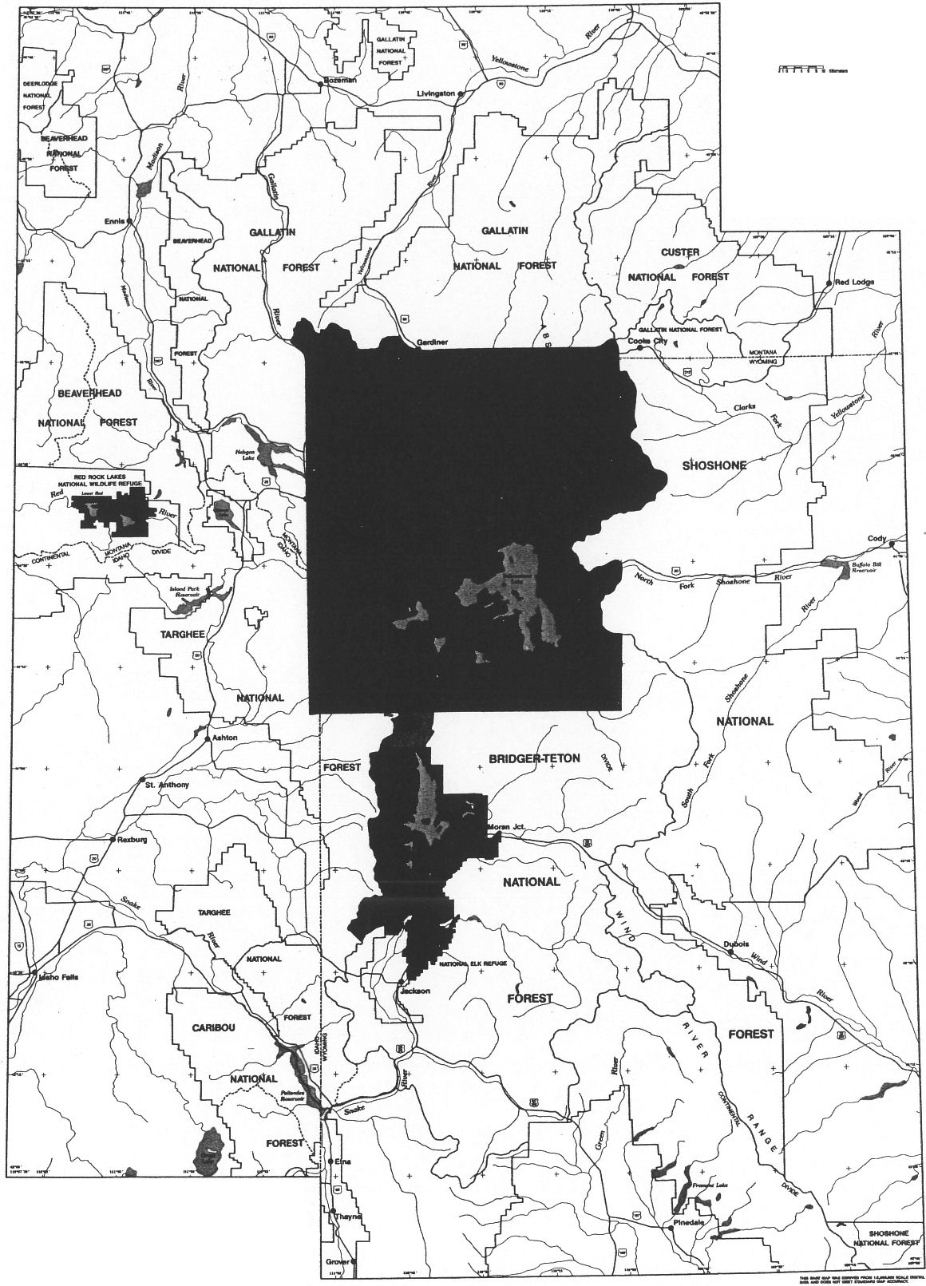
QRIEffEII YELLOWSTONE
AMA
1 1
.,,_
---
==
c::J
---

---- -- -

Figure 1. Greater Yellawstone Area

  - Targhee National Forest, except for the Dubois Ranger District.

  - The portion of the Caribou National Forest adminis­ tered by the Targhee National Forest.

  - Yellowstone National Park.

Grand Teton National Park, including the John D. Rockefeller Jr. Memorial Parkway.

The area as shown in Figure 1 covers 31,000 square miles. Specific landownership figures are shown in Figure 2.

rr.

Since the creation of the first national park and national forest, these two types of federal lands have evolved with distinctly different missions. National forests, under the principles of multiple use, provide the nation with a wide variety of natural resource-related goods, including hardrock minerals, oil and gas, wilderness, watershed protection, livestock grazing, timber, wildlife conservation, and recreation. National parks provide the nation with representative examples of natural landscapes for recrea­ tion, research, and education. Though forests and parks must by virtue of their legislative mandates always be managed differen tly, their missions overlap and are complementary in such areas as research, wildlife conser­ vation, and recreation.

A large acreage of Congressionally designated wilderness

National Forests
!{::::-:;:::
If National Parks •··
···:-: •:·.
1
:: :! I! i Ot her Federal La ds
1
::!:ii:!:s tate Lands
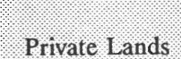

·-.·-:,
··:::····· .·;·: ::::
{\::·
l }ln dian Reservations
.-
- - -
"9,122,000

2,567,000
:' 907,000 ·

_ 685,000
- 4,838,000 •
exists within national forests. Such areas are managed in accordance with the 1964 Wilderness Act and are generally not subject to development activities.

National parks are for the most part withdrawn from mineral development. Timber harvest is not permitted, and watershed and wildlife habitat are retained in their natural state. Some livestock grazing and hunting is allowed in Grand Teton Park, but these activities are st rictlylimited in scope and location. National parks are also subject to the provisions of the 1964 Wilde rness Act, and although no Congressionally designated wilderness exists in Yellow­ stone or Grand Teton Parks, large areas are recommend­ ed and managed as wilderness. Fishing, hiking, camping,

Figure 2. Greater Yellowstone Landownership

Mission of National Parks and National Forests
The key to understanding management of much of the GYA is recognizing differences and similarities between national parks and national forests.

The National Park Service, an agency of the United States Department of the Interior, is responsible for administra­ tion of the national park system. The U.S. Forest Service, an agency of the United States Department of Agriculture, is responsible for the administration of national forests and grasslands.
and motorized use occur in both parks and forests, but are often more intensively managed in parks.

These missions and the current management of the land and resources in the Yellowstone area have evolved through a century of intense thought, debate, and com­ promise. There are 85 federal statutes under which the forests and parks operate, and which are listed in Appen­ dix B.

A complex combination of legislative mandates, geographi­ cal diversity, state and local interests, and world concern for the well-being of the GYA has led to global recogni­ tion of the need for careful and comprehensive coordina­ tion of management goals.

The Management Setting

Since the 1870s, there has been a steadily increasing awareness of the significance of the GYA Yellowstone Park was created by Congress in 1872 in order to protect its remarkable geological and geothermal features. Over the next few decades, conservationists and managers recognized other values of the park, including its wildlife, its role in watershed protection, and eventually its more complex ecological characteristics, so that the national park idea has experienced some of its most dramatic, controversial, and visible evolution in Yellowstone.

Within a few years of the establis hment of the park, the lands surrounding it were also receiving national attention, and efforts were underway to protect some neighboring areas. In 1882, General Philip Sheridan proposed that the park's boundaries be expanded, forty miles to the east and ten miles to the south, primarily to afford the region's dwindling big game additional protection. At the time, there was no other obvious legislative solution than simply enlarging the park boundaries.

Within a few years, leading sportsmen would take the view that the park, with its prohibition on hunting, could serve as a perpetual reservoir of huntable game for the country nearby. These early conservationists were already showing an awareness of the variety of uses available in the GYA, and were struggling to develop administrative systems to match their ambitions.

The first attempt to establish a type of administrative unit distinct from the national park occurred in 1891, when the Yellowstone Park Timber Land Reserve was created to the east and south of the park. It was joined in 1897 by the Teton Forest Reserve, which protected most of the Teton Range and the Jackson Hole Area. That the government was still feeling its way in land management was apparent; the troops that had in 1886 been assigned to protect Yellowstone Park simply had their patrol duties expanded to include these huge new areas, whose timber resources were at first withdrawn from all use.

These reserves became the first national forests, part of what one historian has called "the finest achievement of the Yellowstone crusade." T hus the GYA was the site of both the first national park and the first national forests,

created even before their respective management agencies were in existence. The U.S. Forest Service was created in 1905, and the National Park Service in 1916.

The term "Greater Yellowstone" apparently originated with the famous outdoor writer and novelist Emerson Hough, who in 1917 wrote an appeal for expansion of the park in The Saturday Evening Post. Hough, speaking of local dil!'erences in Wyoming over the idea of expansion, wrote, "Give her Greater Yellowstone and she will inevitably become Greater Wyoming".

But by then it was clear that though administrative bound­ aries were somewhat elastic, they were not removable. The adm inistrative machinery in place by the early 1900s was sturdy enough that Sheridan's original idea, of simply enlarging the park, was no longer readily applicable. It was also becoming clear that the multiple use needs of a growing population for access to natural resources could not be met by a single agency. The missions of the parks and forests bad diverged to the extent that neither could be absorbed into the other.

As Yellowstone Park struggled to deal with ever-increasing numbers of visitors and the host of challenges they brought with them, the national forests of the GYA were facing difficult issues of their own. Early concerns included the capacity of available range to support livestock grazing and the need to schedule timber sales to provide railroad ties and firewood for the growing cities and towns. The movement of wildlife across administrative boundaries was a perplexing issue; the northern and southern Yellowstone elk herds achieved national notoriety by 1920, and generated a debate that·continues today.

The interplay of loca regional, and national interests resulted in many battles that are largely forgotten today. As some people attempted to extend park boundaries, others attempted to make the park smaller. In the 1920s, pro posals were made, and fought over, to remove the Bechler region from the park so that its water could be developed behind a series of dams. For park d fenders, these attempts to reduce the park's values may have reached a peak in the 1933 proposal to divert Yellowstone Lake water by tunnel to Shoshone Lake, and then to the Snake River for use in irrigation.

As time passed competing uses and attendant issues grew. Since World War II, population and economic growth have increased demands on the resomces of the GYA, both for use and for preservation. Such demands have continued to increase the difficulty of maintaining the appropriate balance between land use and preservation.

In the early 1960s, the Greater Yellowstone Coordinating Committee was created , providing a vehicle for easier communication between the parks and forests of the GYA. In those early days of the coordinating process, natural resomce issues were not a major focus of attention of the GYCC. Starting in the late 1960s, the grizzly bear became a topic of national interest, leading managers and conser­ vationists to a heightened recognition of the ecological interrelatedness of GYA lands. By the early 1970s, with the creation of the Interagency Grizzly Bear Study Team, there was growing agency recognition that some resources in the GYA would require cross-boundary management, and growing public interest in seeing such management implemented. Dr. John Craighead, pioneering GYA grizzly bear researcher, has been credited with first using the term "Greater Yellowstone Ecosystem."

Numerous other wildlife species, including osprey, trumpeter swans, bald eagles, bison, and moose, have joined the elk and bears as subjects of interest to those concerned about the well being of the GYA. Most recently, wolf restoration proposals and the fires of 1988 have reinforced and increased public awareness of the ecological wholeness of the GYA. These and numerous other issues have assured the GYA national attention and intense public scrutiny of all management actions, as well as the actions of many other parties residing in the GYA.

But attention on the GYA is not only national. Yellowstone Park is in a world spotlight, and management actions in and near the park are of international interest. The GYA has often pioneered in conservation strategies, and has just as often been at the forefront of wildland management controversies. In 1972, Yellowstone Park became the first American area designated a Biosphere Reserve by the United Nations Educational, Social and Cultural Organization (UNESCO). In 1978, UNESCO named Yellowstone Park a World Heritage Site, suggest­ ing that its significance goes far beyond natural features; other World Heritage Sites include the Egyptian pyramids

and the Palace of Versailles. In short, Yellowstone Park is considered one of the wonders--natmal and cultural--of the modern world, and attention focused on the park also calls attention to the equally exciting lands around the park.

In October, 1985, the House Subcommittees on Public Lands and National Parks and Recreation held a joint Subcommittee hearing on the GYA. The report produced by the Congressional Research Service, Library of Con­ gress, as a result of these hearings, entitled Greater Yellowstone Ecosystem, An Analysis of Data Submitted by Federal and State Agencies, was released in December, 1986. This report stated that there was a relative lack of coordinated information for the entire GYA, and that this lack of coordination was harmful to the GYA's fundamen­ tal values. The report and the hearings, along with increasing management concern and public interest, provided the impetus for intensified coordination of GYA management.

The Coordination Process

The Greater Yellowstone Coordinating Committee began in 1985 to bring together relevant information for the GYA forests and parks. In 1987 the GYCC published the Aggregation, mentioned earlier. The Aggregation combined information from management plans for the national forests and parks in the GYA. Its principle objective was to illustrate the relationship and goals of GYA parks and forests and provide an overview of their management.

To do so it displayed the current condition and extent of resources and management activities. It then illustrated the future condition of the region as the plans were each implemented over the next 10 to 15 years. The Aggrega­ tion was helpful in identifying areas with successful coordination as well as those needing follow-up.

Through the Aggregation the GYCC also announced its intention to accomplish the needed follow-up by over­ seeing an interagency and inter-regional review and analysis of remaining issues and new issues resulting from public review of the document. The final result of the process would be amendments of Forest Service regional guides and forest plans and modifications of park planning·

documents. This process would provide additional coor­ dination of management goals, comparable standards and guidelines for the forests, a consistent approach to display management direction, and policy statements on Park Service and Forest Service coordination.

The first step to accomplish these objectives is the creation of an interagency document to describe desired future condition of the GYA through coordinated management goals and how they can be achieved. The Vision provides this description and sets the stage to complete applicable plan amendments, if needed.

Its basic purpose is to focus both agencies during the management plan and regional guide review process, and to provide a common focus for the individual park and forest plans. As such, it provides the overall view of the GYA, how the cumulative effects of agency plans on region-wide resources are considered, and the structure to resolve inconsistencies that may occur.

The Vision is not a regional plan. It is a statement of principles. It does not make specific land allocation decisions, and does not seek to change the separate missions of the national forests or the national parks. Management principles suggested in the Vision can be accomplished within the existing legal framework, and without either agency going outside of its historic and legal mandates.

The final step in the coordination process is the comple­ tion of whatever amendments may be needed to Forest Service regional guides and forest plans and to the parks' statements for management, general management plans, and resource management plans. Using the principles provided 'by the Vision as guidance, managers will create amendments that display a consistent approach to describe management prescriptions, that contain management standards and guidelines, and that incorporate existing coordinating guideline documents for specific management programs in the GYA.

These amendments, and those that follow whenever forest and park plans are revised, will be documented under the provisions of the National Environmental Policy Act. Thus, actual decision-making will occur under existing

authorities and processes that govern each forest and park and at the time the amendments are considered.

Relationship to Other Ownerships

Four federal agencies, three states, and private landowners make land management decisions affecting six national forests, two national parks, three wildlife refuges, Bureau of Land Management lands, and others. The GYCC itself includes only Forest Service and Park Service managers. The Bureau of Land Management and the Fish and Wildlife Service have appointed liaisons with the GYCC. As issues arise affecting states, counties, and private landowners the GYCC will work cooperatively as describ­ ed later in this document to mutually resolve issues.

The Vision describes the desired future conditions of the parks and forests and how they intend to cooperate with the other important segments of the GYA. It does not imply any government management of privately owned lands. It also does not imply a revocation of any type of valid existing right protected by laws and regulation for any federal permittee or leaseholder.

In several places throughout the document, reference is made to "joint actions," such as "joint analysis" or "joint development " of guidelines. One definition of the word "joint" is "to be regarded as one legal body, united in identity of interest or liability." This is not the definition to be applied herein. The definition to be applied for purposes of this document is: "to be formed by coopera­ tion, or united in action; the nature of the relationship is intended to exchange views and confer; to seek advice or information; and to have regard for and heavily weight and seriously consider the views of the other."

Both agencies will retain the decision-making authorities for the land under their respective jurisdiction. The analyses, assessments, evaluations and guidelines which might be undertaken together all stop short of decision­ making. What is to be gained by this relationship is agreement on the information surrounding a matter needing a decision, a more common basis for understand­ ing. The objective is to improve coordination and enhance the likelihood that decisions once made can be supported by the neighboring agency.

Chapter 2: Public Expectations

Getting to the Goals

The Forest and Park Services vowed in the Aggregation to fully coordinate their management of the GYA. To do this, they later agreed to establish joint goals for the management of the GYA. These goals would describe desired future conditions and would be the centerpiece of the Vision that defined management philosophy for both agencies to use in developing agency plans.

In addition to the goals, the Vision would include a set of "coordinating criteria" recommending how and to what degree each goal could be achieved.

The Aggregation was developed to provide a data base for the GYA and did not require public involvement. The agencies agreed, however, that the development of the Vision would require intensive public involvement. A public participation plan was implemented beginning in May of 1989. It defined the involvement process, and concentrated on the Montana-Wyoming-Idaho region.

A variety of mechanisms, including press releases, Federal Register notices, personal and telephone contacts, open houses, Congressional briefings, listening sessions, mail­ ings, internal agency briefings, and talks to various groups, were employed in this first phase of public involvement. These were conducted primarily by the GYA park superin­ tendents and forest supervisors, the agency public informa­ tion officers, and the GYCC staff. Between May and August of 1989, prior to the publication of the goals, about twelve groups and numerous individuals were contacted. Broad, somewhat philosophical discussions were frequent during this period, and mainly involved special interest groups, state and local agencies, and members of the public. More extensive public involvement did not begin until the release of the draft goals in December 1989.
In September 1989, the forest supervisors and park superintendents met and, using public input, drafted fourteen goals and substantial accompanying philosophy. In December, the draft of those goals and philosophies was released to initiate the second round of public com­ ment.

The Public Reviews the Goals

Almost immediately, there were calls for an extension of the comment period, and the comment period was duly extended until March 1. Comments received well after March 1 were also considered, including those received as late as April 15. ·

The goal packet included the draft goals and a self-addres­ sed postage-paid response form. Four thousand eight hundred goal packets and comment forms were mailed out. By far the largest percentage, upon request, went to organized groups. Five hundred ninety letters were received via this mech anism. They contained 4,851 comments. This period also proved to be one of increas­ ing public understanding of, interest in, and support or concern for the process.

To meet growing public interest, there was a period of intensive public contacts throughout the three-state area. Most parks and forests implemented their portions of the public participation during this period. This included 15 public meetings and open houses, more than 20 public speaking engagements, 6 press releases, 20 briefings with state and federal agencies, and numerous personal or telephone contacts. In addition, 11 regional or local newspapers carried articles, as did numerous special interest publications.

Analysis of the Public Comment

Comments were recorded and categorized based on the goal or issue they addressed. To check the accuracy of the coding process, a random sample of respondents were telephoned to ensure correct interpretation of their com­ ments. The comments were then computerized for addi­ tional analysis. A detailed summary of the comments appears later in this document.

These comments were read for their content, especially specificsuggestions for coordinating criteria, goal organiza­ tion, and areas of special emphasis. They were not regarded as part of a "voting process" by which the GYCC would determine appropriate management directions, but were used along with scientific data, laws, regulations, and other information to develop the draft Vision.
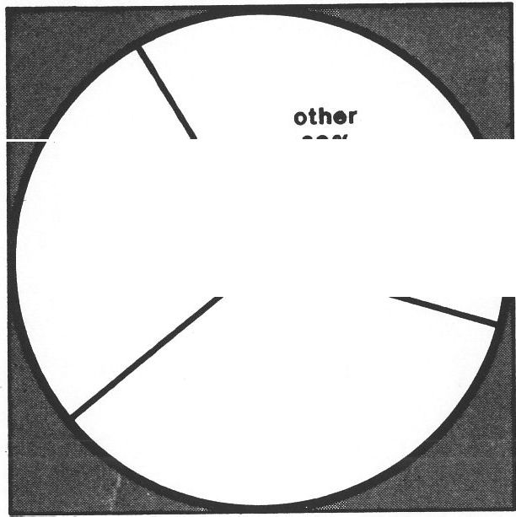
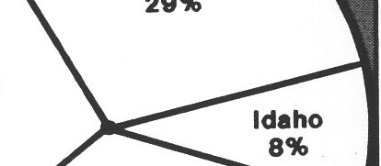
other
29%
Wyoming
28%
Montana
35%
Figure 3. Origination of Comments

The ·10· Team

The inter-disciplinary team (hereinafter "the ID Team") was established to write the detailed coordinating criteria based on the draft goals. The ID Team was composed of six specialists from various Forest Service and Park Service units, three from each agency. They reviewed the goals

using the public comment and expertise from all sources, and then drafted coordinating criteria and accompanying text, completing this task in mid-April.

As will be seen in Chapter Three, the team responded in many ways to public comment. Many specific suggestions were incorporated into the coordinating criteria, but most immediately evident is a complete restructuring of the goals and coordinating criteria. There are now three goals, grouped around the three obvious areas of public interest. This approach brings a different balance to the presentation, and was perceived by many commenters as necessary because it allows for a clearer organization of subject matter. The restructuring was accomplished without reducing the level of detai and without neglecting any topic covered by the original fourteen goals. Within this new structure, many of the goals were revised or rewritten to reflect public concerns, and in several cases goals were combined.

In late April and May, the forest supervisors, park superin tendents, regional foresters, and regional director·review­ ed, amended, and ultimately approved the goals, coordi­ nating criteria, and other elements of the Vision for release to the public for the second "round" of public comment. That draft is what you are now reading.

The Next Steps
This draft was produced using management knowledge and public comment. It represents how the Forest Service and Park Service plan to coordinate management of the lands under their responsibility in the GYA, and it reflects extensive public comment. This draft will also be open to public comment and review for at least 60 days. After this period of public comment, the ID team will prepare a final draft of the document for managerial review and approval.

Your comments are once again encouraged. Once the Vision is in final form, it will be used as "recommendations to management" to amend or revise the regional guide and forest and park plans as needed.

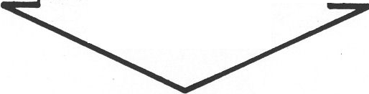
Comments on Specific Goals
1987
"Aggregation of F oreet
& Park Plane" publlehed
need to prepare
- •vision• Identified

What is the appropriate balance between Naturalness and Sustainable Economic Opportunities? Goal 1 (Conserve the Sense of Naturalness) and 2 (Encourage Sustainable Economic Opportunities)

Figure 4. Time Une for the Vision
The majority of respondents felt these goals were unclear or inherently in conflict. Many wanted "naturalness" to be the overriding goal. Others felt strongly that there needed to be a clear statement that the Forest Service multiple­ use mission would remain unchanged. They pointed out that in their minds the Forest Service is legally obliged to consider economics. Others felt the Forest Service need only consider economics and what was needed was a comprehensive economic study. Some felt that develop­ ment in the national parks already fails to meet the standard of naturalness. Others reminded us that recrea­ tional development can be as, or more, detrimental to ecosystem values as grazing, timbering or mineral develop­ ment.

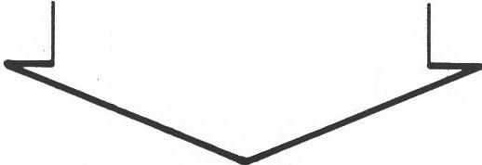
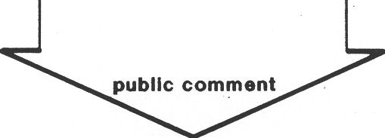
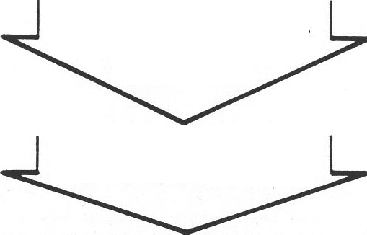
Still others voiced a strong concern that "constraints" or additional regulations can have the effect of eliminating a commodity use. Grazing was viewed as a dichotomy by many as it contributed to the rural life style, economic viability, and wildness but many felt sensitive habitats, such as riparian areas, were being seriously affected. An analysis of the impacts of grazing and recommendations for mitigation were called for. Others pointed out that if uses like livestock are uneconomical the land will be sold and "urbanized" and the ecosystem will suffer.
1988
begin preparation of "Ylelon" Informal publlc Input
1989
14 draft goal• for "Vlelon" published publlc comment
August 1990 draft "Vlelon" publlehed
October 1990 public comment clo•e•
for draft "Vlelon"
agency review
winter 1990-1991
flnal "Vision" publlehed

Some called for an initial environmental review process that would address ecosystem values and cumulative effects. Some felt that the 19% of the forested lands currently available for timber is not enough nor can they count on timber sales. Others responded that the wildlife benefits of timber harvest practices are seldom real. The oil and gas industry called for a clear statement of the laws and regulations protecting their economic interests and a statement that no more areas would be "withdrawn" and no more restrictions would be added. Environmental groups called for the emphasis to be on minimum impact recreation.
begin "Vlelon" Implementation
forest regional guides amended forest & park plans amended
(If necessary)

These two goals seemed to garner the most "votes• for an "either/or" management but also seemed to best represent the challenge of balanced uses of the GYA. One consis­ tent message from almost all groups and individuals was an affirmation of the fundamental premise that the Greater Yellowstone is special to the American people, including local residents, and management should recog­ nize its importance.

How can both agencies better manage to recognize that
  - natural processes and interrelationships cross ad­ ministrative boundaries? Goal 3

Most comments supported this goal. The suggestion that agency boundaries be realigned or changed was made. Some suggested that the area be managed as an ecosystem and the park be reduced or eliminated. Many people commented that data bases, research, cumulative effects, and cooperation should be emphasized more. Fir·e and weed management were seen as important in the eco­ system and greater coordination was urged. Many com­ ments were made about the Interagency Grizzly Bear Committee. Most supported it or wanted it expanded; others felt it was a poor example to cite; still others thought enough had been done for the grizzly. Some groups suggested that the negative effects of agency decisions needed to be recognized and eliminated or reduced. Still others called for the development of ecosystem-wide plans for various resources. Legal public access was seen as an issue. This goal was seen by a majority of groups and individuals as a key to the success of better "coordination and ecosystem management".

How can the Forest and Park Service manage to provide
high quality recreational experiences? Goal 4

Many members of organized snowmobile groups wrote in to express their desire for more mechanized recreational opportunities. These included opening national parks, extending trails, and reduction of regulation. Most environmental groups cautioned that not all forms or levels of recreational development are compatible with the ecosystem. Many people commented that the present mix of recreation on forest and park lands is good and should be continued or expanded.
How can we protect the visual experience in major travel corridors? Goal S

Comments on scenic corridors pointed out that while there was general support for the goal, they believed some important points were missed. First, many comments pointed out that scenic corridors extend into and through national parks and concern for the visual quality inside parks should be as great or greater than outside. Specific park issues of highway construction and design, concession and administrative facilities, and employee housing were mentioned as problems. Some groups and individuals felt that oil, gas, mining, and logging should be restricted or eliminated in travel corridors; others felt that if these activities were temporary and "well done" they were a part of the visitor experience. Generally comments encouraged cooperation with private and local entities to enhance, maintain, protect, or restore the "visual experience."

What is the level of biological diversity and how can it be improved or maintained? Goal 6

Many respondents disagreed that the current level of biodiversity is generally good. They called for the return of the wolf, elimination of predator control, and restora­ tion of some fisheries resources. They also called for greater protection of the grizzly bear gene pool and habitat, including removal of the Fishing Bridge develop­ ment in Yellowstone Park. Some saw roads as a major threat to biodiversity and called for an analysis of cumula­ tive effects of roads in GYA. Still others wanted a moratorium on road building until it was fully evaluated. A few saw biodiversity·as a "cloak" for preservation. Some said biodiversity is undefined so it should not be used as a coordinating criteria term: Some timber groups sup­ ported the goal and saw new concepts of silviculture (timber management) as a tool to enhance biodiversity. Others opposed even including it in the goals. Agricultur­ al interests commented that grazing can also be a tool if the number of grazing animals is balanced and is consis­ tent with seasonally available forage. They offered to work with the agencies to develop monitoring and mitiga­ tion plans.

Many others called for an ecosystem wide assessment of biodiversity with a focus on habitat for threatened and endangered and sensitive species. Some called for a ban on all large-scale activities until it can be demonstrated that projects will not harm biodiversity in the G YA. They also called for implementation of all the recommendations in the IGBC "Grizzly Bear Compendium•. Public com­ ments clearly called for a tie between management objectives for biodiversity and an ecosystem-wide data base. Almost all groups commenting on this goal call for a clearer and more current definition.

What level of protection is appropriate to ensure the integrity of the geothermal systems? Goal 7

This goal received nearly unanimous comments of support from all groups and individuals. Industry pointed out that the agencies have a responsibility to do the research necessary to map and delineate the geology of the geo­ thermal resources. They also commented that the National Environmental Policy Act (NEPA) already requires full analysis. Environmental interests commented that we should err on the side of extreme caution and that NEPA only requires that a decision-making process be followed. Many groups and individuals urged that devel­ opment of private lands be managed so as to avoid harming the geothermal resources. State or federal legislation and cooperative agreements were suggested as mechanisms to protect geothermal resources.

How can we maintain the present air and water quality in the GYA and should we be doing more to improve it? Goal 8

Again there was broad support for this goal from most groups and individuals. Class I air quality designation was called for in all or portions of the GYA. Most comments supported designation of all wilderness areas in the GYA as class I air quality. Stricter enforcement of state and federal air and water regulations was cited as important. State governments reminded us of their important role. Individuals commented "air and water quality" is why we live here. Industry commented that new regulations or restrictions were unnecessary and the economic impacts were unacceptable. They also pointed out that the GYCC
has no authority "to exceed" the present legal standards for air and water quality. Many called for the addition of soil to this goal. Smoke from the 1988 fires was frequently
mentioned as being unacceptable. Others felt fire was such an important management tool that variances needed to be made in the case of smoke from natural fires.

How can we manage to allow natural processes to func­ tion in National Forest Wilderness and National Park Backcountry? Goal 9

This goal provided some of the more diverse comments. Most commenters supported the goal in backcountry and wilderness, but some state and federal agencies, as well as some groups and individuals, felt that this goal and Goal
14 (wildlife) would be in conflict. Others called for analysis and greater control of activities currently occurring in wilderness. Still others said "fine for wilderness and back country, but don't expand to the whole GYA." Many pointed out that the whole concept is contrary to the stated goal of ecosystem management. Fire was seen as necessary, but many people said the 1988 fire situation was extreme. Suggestions to study and improve grazing, riparian areas, wetlands, and recreational and outfitter use were frequent.

How can we manage backcountry recreational experiences to complement wilderness and undeveloped areas? Goal 10

There was considerable divergence of opinion and depth of emotion associated with comments on this goal. Comments ranged from "manage all roadless areas as defacto wilderness" lo "get rid of wilderness". Many organizations called for a coordinating criteria that set a policy of "no net gain" in roads in the GYA. Many felt that roadless areas should remain roadless, but should provide a greater array of recreational opportunities than is allowed in wilderness. But the kinds of comments of what recreation would be appropriate varied considerably ranging from mechanized uses such as 4-wheel drive to foot access only. Some organizations and many individuals called for better management of all recreation, including careful analysis and a willingness to eliminate roads and trails if they conflicted with other values. Grazing and

timber interests commented that recreation can have as many or more negative impacts on ecosystem values as commodity uses.

How can the agencies better manage historic and cultural resources? Goal 11

Although this goal received by far the fewest coµiments, it received the largest proportion of comments like "Great", "Terrific" or "I agree." Many comments called for a GYA inventory and interagency action plan which includes the states. Suggestions were made that the "Indians need to be written back into the history of the GYA." Others suggested that the historic structures, unusual geological features and archeological resources should be part of Goal #1. A few commented that this goal should be subservient to natural resource objectives in the GYA. Generally speaking there was little opposition to this goal although some caution was made that "priorities need to be established and followed" - "Not everything is worth saving."

How can we better promote education and understanding through public and private cooperation? Goal 12

Public comment generally encouraged more communica­ tion, education, and cooperation. Holistic education, including the role of grazing, mining, timbering, and man as part of the ecosystem was called for. Comments urged us to avoid the "nature is good, man is bad" approach but rather to emphasize that mankind has the ability and responsibility to decide what uses and levels of use are appropriate in this or any ecosystem. Factual, unbiased information was stressed. Offers of help and cooperation were received as comments.

How can we improve our cooperation with other govern­ mental and private entities? Goal 13

The public, including other governmental agencies, had many comments on how to better cooperate in the GYA. Generally it was viewed as one of the most important, but also most difficult goals to achieve. BLM, U.S. Fish and Wildlife Service and state governments were seen as
players that should be formal members of the GYCC. To be meaningful, many saw the need for consistent and shared information bases, legal agency mechanisms for inv<;>lving all interests, and legislation to implement discus­ sions. Some groups recommend this as the number one goal. Others cautioned cooperation for misguided or unclear purposes could be a waste of taxpayer dollars. The clear implication of the public comment on this goal was "we need to do more and do it better".

How can we best retain the fish and wildlife resources in the GYA? Goal 14

Comments on the goal were found as elements of Goals 3 and 6. This goal also seemed to elicit the most specific recommendations for actions. The overriding comment was the need for cooperation, goal setting, joint research, and education by all the "stakeholders," including state and federal agencies, private landowners, and conservation organizations. Specific actions recommended included restore or maintain the "natural mix" or the present mix of fish, restore wolves, set or control population levels of big game, establish winter range needs, avoid game farm approach, and use best timber management practices. This goal seemed to also evoke the most "vote casting" comments in favor of one agency's wildlife management practices or philosophy.

Other Issues and Major Comments.

Comments and suggestions were received to add goals or suggesting coordinating criteria. These tended to be issues that were not included in the Vision but are of great concern to the public. Those issues were:

- Extend the Biosphere Reserve to the entire GYA.

- Restore wolves to the GYA.

- Control fire.

- Let fire policies continue.

Vision for the Future
A Framework for Coordination in the Greater Yellowstone Area

2-6

- Funding needs to be attached to this effort to insure recommendations will be implemented.

- Threat ened and endangered species need to be added as a separate goal.

- Some of the goals needed to be combined to simplify and clarify this document.

- The coordinating criteria should be separated by agency so it is clear that agency mandates and legal responsibilities are not violated or undermined.

1-neturalneH 2-economlca
- ·l» "l-..
)11· .
-=-.1:: -
.,_
._ . --
"• /V,• '' -•.•" ·t- "• ,,
.
3-lnterreletlonahlpa

4-recreetlon 5-acenlc corridor• 6-blodlveralty
7-geothermel 8-elr & water
9-neturel proce•••• 10-enhence backcountry
11-hlatorlc 12-educatlon 13-cooperatlon
14-flsh & wildlife

100 200 300 400
number of responses

Figure 5. Comments Per Goal

Chapter 3: The Vision for Greater Yellowstone

Any proposal for the future of the GYA must take a realistic view. As in the past, there will be disputes and controversies over management direction; those are routinely part of the democratic process, and when conducted in a constructive spirit are often the best avenue for resolution of conflicts. If it were actually possible to create, or even envision, a perfectly managed GYA in which all parties and interest groups were fully satisfied, the following goals and coordinating criteria would hardly be necessary.

What follows, then, is not unreasonably optimistic; it does
In these grand settings, ecological processes will be apparent at all scales, from the geological time scale of canyons being carved by rivers to the swift, moment-by-moment pace of life in a prairie-dog town. Further, the complex interrelationships of all the pieces, from the largest river to the smallest life forms, will be not only evident but also carefully protected and interpreted. The overriding mood of the GYA will be one of natural­ ness, a combination of ecological processes operating with little restraint and humans moderating their activities so that they become a reasonable part of, rather than en­ cumbrance upon, those processes. (See page 3-9.)

not pretend that conflicts will not occur·. But it does

assume that the GYA can serve many people well at the same time that its fundamental values· are adequately protected . This brief narrative vision is based on reason­ able expectations. The goals and coordination criteria that follow this narrative outline how those expectations can be fulfilled.

There is considerable discussion of the concept of show­ casing industries. The Forest Service and Park Service will recognize, however, that all aspects of the management and use of the GYA, not just those involving industry and commerce, must measure up to a high standard. The GYA is not only a laboratory and classroom for the public and the scientific community; it is also an extraordinary opportunity for managers to improve their skills.

Future visitors and residents of the G YA will encounter a landscape where natural processes are operating with little hindrance on a grand scale. The many panoramic vistas of the GYA will provide much more than static, post-card images of photogenic forests; they will show nature busily doing what nature has done here for thousands of years. Forests in various stages of succession, unda mmed water­ ways, huge, unpolluted lakes and accompanying drainage basins, will all reveal natural processes at work.
Complementing that mood will be opportunities, foremost of which may be education. The GYA will becom e a
- world model, a showcase of progre ssive management of public and private resource s, and of cooperation among many agencies, groups, and individuals to achieve goals. The showcase will be of many parts.

Socio-Economic Values

The GYA will continue to provide a diversity of liveli­ hoods. Opportunities for recreation and commodity development, including timber harvesting, grazing, and mineral development will be provided for on appropriate federal lands. The agencies will ensure that proposed developments are designed in harmony with the resources of the GYA.

The GYA provides an excellent opportunity to demon­ strate that recreation uses and commodity development operations can be designed in ways that are sensitive to other resource values and uses of the land. When such developments are no longer operating, the land will be reclaimed for other beneficial uses in harmony with the surrounding area. Opportunities will be provided for people to see and understand commodity developmentand

recreational uses in an environmentally sensitive region. The agencies will provide incentives to encourage invest­ ments in research and technology that enhance these model operations.

Communities and industries will provide quality services and opportunities that complement the unique natural values of the GYA, operating in ways, and at levels, that recognize the national and international significance of the wildlife, recreation, scenery, thermal features, and wilder­
Livestock and agricultural industries will continue to be important in the economy, as well as in maintaining the largely rural appearance and character of the GYA. Grazing of livestock on forest lands will be integrated with other ecosystem values. Special attention will be given in range management decisions to sensitive areas, such as riparian zones. Grazing will be used as a vegetation management tool where appropriate. (See page 3-28.)

Oil, gas, and mineral development will continue, with full

ness.
protection of valid existing rights·.
Mineral operations will

Recreation and its associated service industry, account for nearly two-thirds of annual income generated. Recreation will continue to be the predominant economic force in the area. The area will continue to provide a wide array of recreational opportunities. The recreation and service industries will support this spectrum of opportunities, ranging from motorized and non-motorized use to wilder­ ness treks, etc. (See page 3-31.)

There will be a sustainable timber industry in which timber management will be performed to meet land management objectives and provide for the integrity of the ecosystem and the natural appearance of the area. The presence of a local, skilled, timber industry is important in the maintenance of an existing lifestyle and community stability, and in carrying out needed forest management objectives such as timber stand improvement, reduction of hazardous trees in recreation areas, and manipulation of fuel levels and wildlife habitat. (See page 3-35.)

Timber communities will be encouraged to diversify their industries to increase economic resilience. Rather than rely entirely on the extraction of timber to provide local jobs, there will be more reliance on industries that pro­ duce products from the timber rather than exporting it raw from the GYA. Using wood fiber to manufacture· prod­ ucts locally will also provide a more sustainable wood products industry. The Forest Service will help identify production opportunities through their research programs, and will work with local communities in applying for grants to assist in economic transitions. (See page 3-27.)
be conducted in a manner that allows economically viable extraction of the mineral resource while protecting eco­ system values. Over the next decade, data, tools, and technologies will become available to conduct a com­ prehensive assessment to evaluate mineral development potential and associated impacts across the GYA. Mineral development will be permitted on national forest lands except where geothermal resources are shown to be at risk, and where it is both legally allowable and otherwise appropriate. (See page 3-29.)

Air, Water, and Soil
The GYA will have high quality air and water. Managers will ensure a continuation and protection of the unparal­ leled visibility in the area, and wilderness areas will have class I air quality status.

The soil, water, and air resources of the farm, ranch, range, and forest and park lands are basic area assets. The wise use and management of these natural resources are necessary to preserve and promote the health, safety, and general welfare of the people who live here.

Future generations will be able to rely on these resources. Air quality, water quality, and soils specialists from local, state, and federal agencies will work together to inventory, monitor, protect, and, where feasible, restore pristine air, watershed, and visibility resources. Together they will ensure that the GYA meets or exceeds the requirements of both the Clean Air Act and Clean Water Act. (See page 3-12.)

Biological Diversity Fish and Wildlife

Visitors and residents will share the area with a variety of native life communities--from the simplest to the most complex--that are representative of those to be expected in this part of North America. In these communities will occur a full complement of native plant and animal species that would typically occupy each community. Humans will experience the GYA with the assurance that each species is secure from the problems of genetic isolation resulting from undesirable manipulation of its population or en­ vironment. (See page 3-15.)

Cultural Values

The GYA's rich legacy of past and present human cultures will receive its fair share of attention and respect. This area has been special to people for a long time; scattered throughout the G YA is evidence of eleven thousand years of human use. Hundreds of prehistoric and historic sites have been discovered and untold more remain to be found. From arrow heads, petroglyphs, and teepee rings, to old bullet casings, graves, homestead sites, mining operations, and garbage pits, the GYA contains valuable treasures to be preserved and interpreted for public enjoyment and education. They will help us understand the lives and ways of those here before us, and will inspire our collective imagination to appreciate how it might have been "back then• when Indians, trappers, soldiers, home­ steaders, loggers, and miners made this region their home.

Archeologists and historians from state and federal agencies in the GYA will work together to locate, protect, and interpret these valuable cultural resources. The story their research will tell will be of the entire GYA rather than of isolated local sites and landmarks. (See page 3- 18.)
Visitors and residents will encounter naturally supported populations of native animals, or carefully managed introduced species, in densities and distributions controlled primarily by available habitat. These habitats will be managed for their internal integrity and well-being rather than as a reflection of administrative boundaries.

Sportsmen will encounter a wide variety of recreational opportunities that emphasize the values of pursuing game under such conditions. Others who enjoy the wildlife resource will be provided abundant opportunities to experience animals as part of the natural system. Re­ searchers will have numerous opportunities not only to study specific animals and their ecological settings, but also to study animals in a variety of settings and under a variety of management mandates and approaches. (See page 3- 19.)

Geothermal Features

With more than 200 geysers and 10,000 hot pots, boiling springs, and other geothermal phenomenon, Yellowstone Park encompasses the largest, most diverse and intact display of these features to be found anywhere on the planet. Therefore proposed projects on adjoining forests will be thoroughly analyzed through the National Environ­ mental Policy Act process. Projects permitted will have to be shown to be without potential to harm geothermal features. Research to identify sensitive individual features, systems and their components, and the relationship of the geothermal features to surrounding lands and subsurface values must proceed promptly in order to answer legiti­ mate questions about where there will not be risks.

Through research, regulation, and the exercise of extreme caution, the GYA will be assured of the continued health of its many spectacular geothermal features. These features will continue be a major attraction and education­ al feature of the GYA, and will continue to inspire and educate. (See page 3-22.)

Wilderness

Wtldemess in the GYA is acknowledged to be a -reso urce in its own right. As such, management will be the mini­ mum necessary to secure maximum protection of the wilderness resource. People seeking to experience wilder­ ness will continue to find an abundance of such lands in the GYA. Here, to an extent found in few other parts of the lower 48 states, people will be able to learn what wilderness is--to enjoy vast panoramas of virgin forest, or reach remote areas miles from the nearest road.

The wilderness of the GYA will remain important to the American people not principally as a backdrop for primi­ tive recreation, education, and research, but more impor­ tantly, simply because it is wild. Its intrinsic values will be held in trust for future generations. (See page 3-24.)

Recreation

World-renowned natural and cultural resources exist in the GYA that provide the scene for meaningful and enjoyable recreation opportunities for a variety of quality individual and group experiences. Recreational activities which lead to an understanding and appreciation of the natural character and ecological integrity of the GYA will be emphasized.

The different missions of the parks and forests provide opportunities, during all seasons, for a broad spectrum of dispersed, quality recreation experiences and services in the context of a unique natural setting. The recreational use in each forest or park will complement activities in other forests or parks, and these opportunities will be enhanced and supported by additional, and complemen­ tary, recreational activities on private and state lands;

National and international visitors to the GYA are spec­ tators or participants in motorized or non-motorized activities, some of which are once-in-a-life-time experien­ ces, during all seasons of the year. Activities include, though are not limited to, driving through scenic byways, hunting, mountain climbing, sight-seeing, boating, water skiing, fishing, hiking, snowmobiling, downhill skiing,
viewing wildlife, boating, backcountry or front country camping, naturalist programs, viewing archeological sites, and camping in remote areas. (See page 3-31.)

Coordination

The GYCC will work together in coordinating manage­ ment across jurisdictional boundaries and will cooperate with state and local governments and private landowners. The missions of the federal agencies, as well as the values and rights of the states and private landowners, will be preserved. This will provide for complementary manage­ ment and use between agencies, state and local govern­ ments, landowners, and the general public while preserving the ecological integrity of the GYA. (See page 3-39.)

Natural-Processes that Cross Boundaries
One of the greatest challenges facing not only managers but the public is becoming familiar with a larger, more comprehensive sense of scale. Just as the rangers on adjacent park and forest districts must recognize that they are managing the same ecological unit, so residents of local communities must realize that they are all citizens of the same region. Involved parties will be most effective if they are acquainted with the language and emphasis of modern ecosystem sciences, including cumulative effects, linkages, corridors, fragmentation, and economic impacts.

Fire

Fire has been a significant natural force in shaping the flora and fauna of the GYA. Continuation of these natural processes is desirable in much of the area. Forests and parks may use manager-set prescribed fires to ac­ complish land management objectives ranging from hazard fuel reduction to assisting in the reintroduction of fire to its natural role in the environment. They will also con­ tinue to use prescribed natural fires (those fires ignited by lightning) to achieve defined objectives.

Education
The GYA is one of the world's great natural laboratories. Extensive current and past research has provided abundant information on resources and ecosystem processes. The high quality visitor centers, museums, and other interpre­ tive facilities, both public and private, provide a unique opportunity to use this information to educate millions of visitors about the natural world and how people can use and enjoy it. The Forest Service and Park Service will work cooperatively with other agencies, organizations, and communities to foster greater visitor enjoyment and understanding. When possible, programs will be co­ ordinated and facilities shared . (See page 3-42.)

Sharing Information
A primary goal of improved information interchange is public access. It will be possible for a concerned citizen to sit down at a computer terminal, whether at home or at a university or other library system, and gain access to much of the huge amount of information already in the public domain in the GYA. This can be accomplished with full respect for the professional rights of all research­ ers to unreleased or unpublished data, and will greatly ease the current problems with information exchange between federal agencies and the public. Such a system would be of inestimable benefit to agency personnel as well. (See page 3-39.)

Conclusion
In short, it might be said that those GYA constituencies hoping for a so-called "lockup" of the area's resources will be disappointed, but that those elements hoping for a "business-as-usual" approach to GYA industries will likewise be disappointed. The GYA pie can only be divided up in so many ways. The perpetuation of the natural and cultural values that have made this area the object of intense national and international affection and concern will be the foremost goal of management, because through that goal the GYA will best serve its many constituencies far into the future.

Goal: Conserve the Sense of Naturalness and Maintain Ecosystem Integrity.

The overarching goal is to conserve the sense of naturalness and maintain ecosystem Integrity in the GYA through respect for ecological and geological processes and features that cross administrative boundaries. This will result in high-quality air, and water, complete protection for fragile geothermal features, and maintenance or restoration of biological diversity and resulting fish and wildlife populations. These results will enhance the recreational and residen­ tial qualities of the GYA, to the advantage of well-established ecologi­ cal and cultural communities.

Conserve the sense of naturalness and maintain ecosystem integrity through­ out the Greater Yellowstone Area. (Page 3-9)

Maintain or improve air, water, and soils in the GYA. (Page 3-12)

Maintain or improve biological diversi­ ty. (Page 3-15)

Manage the historic, cultural and ar­ cheological resources to enhance their role in the visitor experience and for their scientific value. (Page 3-18)

Retain the world renowned fish and wildlife resources. (Page 3-19)

Ensure the integrity of geothermal features. (Page 3-22)

Protect wilderness values and resolve remaining wilderness classification issues in the GYA. (Page 3-24)

Conserve the Sense of Naturalness and Maintain Ecosystem Integrity Throughout the Greater Yellowstone Area

Discussion

Naturalness will mean different things to different people, and defining it is made even more difficult in this case by the addition of "a sense of' to the word. In any given group of people, definitions of what is natural will range along a continuum, from "anything humans, especially modern technological humans, have not affected," to "everything humans now or once did effect_K These definitions are the results of deep cultural, social, and religious value systems.

Rather than accepting any single definition of the term, in this Vision, naturalness is approached by recognizing the entire continuum of definitions. Recent scholars of nature philosophy have suggested that naturalness can be seen as
a relative quality. That is, the extent to which natural processes, such as plant succession, animal population dynamics, and other elements of an ecological setting are functioning without major disruption by humans is a measure of their relative naturalness.

Such a view, reasonably applied, does not perceive human effects on the landscape as somehow "evil" or "good,• but it does allow for recognition of their influence. The extent to which this view considers nature as a setting exclusive of humans will still depend upon the perspective of each individual. The federal agencies, by virtue of their respec­ tive mandates, are not permitted to consider humans as somehow exclusive from natural settings, simply because the Forest Service and Park Service are managing public lands in the GYA for the benefit of human society.

Visitor or resident expectations of naturalness in the GYA vary depending upon the background and experience of each visitor. A family from an urban area may find GYA

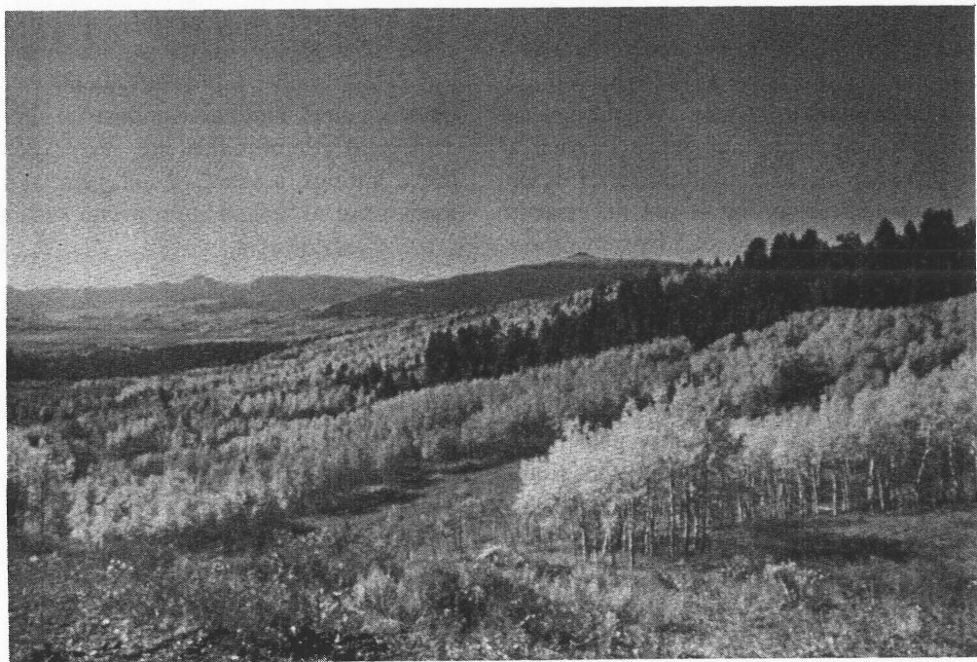

Aspen in the Greater Yellowstone Area.

i
I
I

I
i
.1.
!

'_{j}
·1
ranches and pastoral views "natural." An avid backpacker may only find "naturalness" in a remote backcountry area. The rancher does not regard his or her home as a rem­ nant of simpler times, rather for him or er it is a means of livelihood. Somewhere in the 11.7 million acres of the GYA, each person can now and should always be able to find areas that match their personal definition of natural­ ness.

Nonetheless, for practical purposes the Forest Service and Park Service do need to agree on what management direc­ tion is established by this particular goal. For the purposes of directing management actions, a sense of naturalness is defined as that state in which landscapes appear, and ecological processes operate, much as they would without the effects of modern man even though man and his activities occur. In other words, man's activities are carried out so that they harmonize with, rather than intrude upon, the landscape.

It is well known among ecologists, for example, that human presence or development in a largely intact eco­ system could conceivably have only minor effects on the overall functioning of that ecosystem. Human presence may at the same tim·e be troubling to· certain users of that ecosystem, such as the backpacker mentioned earlier, and may be comforting to other users, such as the urban family accustomed to densely populated country. Whatever way each individual responds to human presence in such a setting, it must be recognized that human presence in, or interaction with, an ecological setting is not necessarily proof that the setting's ecological processes have lost their integrity.

Prehistoric American Indians provide an illuminating example of the complexities of the naturalness issue. Recent paleoecological research suggests that the no.rthern region of Yellowstone Park has hosted very nearly the same fauna for the past 2,000 years. During that time, American Indians without doubt occupied and used the area in varying numbers, and at times may have had effects on wildlife distribution, fire occurrence, and other ecological matters. The current state of knowledge about American Indian influences in the GYA is insufficient to
allow confident detailed conclusions, but it does appear that most major ecosystem processes continued to occur during that 2,000 years (at least until the arrival of Euro­ pean humans) without dramatic changes in species diversi­ ty.

Current managers cannot, based on existing information, pretend to equate any portion of modern human influenc­ es to prehistoric human influences, and no such equation is suggested. What is proposed, however, is that we have ample evidence to suggest that humans, whether they are considered natural or not, can be a part of the GYA without altering its ecological processes beyond a reason­ able definition of natural.

It is in this spirit, of humans interacting without seriously altering, that "naturalness" is put forth as a criteria for management of the GY A. In many portions of the GYA, existing law already requires what are by almost any standard very high degrees of relative naturalness. In other portions, existing law, established human uses, and private property rights have often already assured that lesser degrees of relative naturalness will prevail.

It is in consideration of these areas that the modifier "a sense of' is applied to "naturalness." In numerous areas of the GYA, such as bordering communities, larger park developments, and some industrial sites, the processes of ecological communities are restricted or truncat ed. In these settings, a sense of Raturalness can be achieved in many ways, as judged appropriate and sufficient by manag­ ers and landowners.

On national forest and national park lands, manag ers seeking to maintain or create a sense of naturalness will be guided by the principle of harmonizing with ecological processes. This translates into both reduction of intrusions in actual ecological processes (as in making sure that road culverts do not block fish migrations), and reduction of the appearance of int rusion (as in cho osing appropriate construction designs and procedures, and finishing materi­ als, to make a building blend with, rather than stand out from, its setting). For example, in the Forest Service, the concepts known as "New Pe rspectives" and "Change on the Range" recognize these values by committing to manage

national forests and grasslands for their full array of values and benefits, especially for ecological sustainability and long-term productivity. See glossary for a complete definition of these terms.

This goal already has extensive basis in existing law, and it sets the management philosophy for all activities of both the Forest Service and the Park Service in the GYA. In the GYA, the two agencies will work together to set an example, to ensure that human activities harmonize with the central values of the land. Likewise, they will work with their neighbors to foster a cooperative spirit in protecting and using these treasured resources. They will also foster research to refine and improve understanding of ecological processes, so that whenever possible a deeper understanding of the concept of naturalness can emerge.

Coordinating Criteria

  - Management and development acttv1t1es will be designed to be unobtrusive and in harmony with the natural landscape. Visitors to the GYA will not encounter significant, abrupt, man-caused changes in the landscape as they travel through the area. Major highway travel corridors leading to the national parks and national forests are an integral part of the visitor experience, and will be managed by both agencies to retain a vast natural setting. A process will be set in place to identify important corridors in the G-YA. Landscapes in these corridors will remain in a natural-appearing condition where activities such as timber harvests, mines, oil and gas operations, and recreation areas will usually be unnoticeable to the casual observer. The natural integrity of the area will appear intact. Restoration will occur as necessary to restore visual quality.

  - Ecological processes will operate as freely as possible. Managers will make decisions on the basis of analyz­ ing proposed activities or policies in terms of the GYA as a whole, as well as on unit-specific co ider:­ ations.

  - Management of resources will maintain natural settings or restore them over time. Multiple-use activities on the national forests will be conducted in environmentally sensitive ways, not only for the pro­ tection of ecosystem values, but also to provide examples of ways in which large landscapes can be protected and yet provide a wide range of human resource needs. These activities will also maintain professional skills, such as logging expertise, needed by managers to achieve other ecosystem goals. Once human-caused impacts have occurred, restoration will occur in a manner that closely replicates natural conditions.

  - The Forest Service and Park Service will work togeth·- er to ensure that the scenic resources of the GYA are protected. This will be accomplished by establishing visual-quality objectives for all forest and park lands in the GYA. Emphasis will be given to visual quality objectives that maintain naturally appearing land­ scapes where evidence of management activities are subordinate to the landscape. The GYCC will seek opportunities to cooperate with landowners to encour­ age visual quality objectives for lands lying in aestheti­ cally important sites adjacent to forests and parks, particularly near gateway commu nities· and GYA entrance corridors.

,.

Maintain or Improve Air, Water, and Soils in the GYA.

Discussion

Federal land managers, including the Forest Service and the Park Service, have an affirmative responsibility to protect the air quality and air quality-related values of the GY A. Congressional direction is clear on this point: "... While the general scope of the federal government's activities in preventing significant deterioration has been carefully limited, the federal land manager should assume
'! an aggressive role in protecting the air quality values of
:1 land areas under his jurisdiction ... In the case of doubt t e Ian manager should err on the side of protecting th;
:I arr quality related values for future generations."
:I
>
Public comment strongly supports maintaining or improv­ ing the quality of air and water resources in the GYA. GYCC endorsement of redesignation of wilderness areas to class I air quality status or protection of viewsheds will
- I I not eliminate all other uses in the area. Redesignation is
I an action that can only be taken by the states.

Class I air quality status sets in motion a process by which the affected states make decisions on specific projects, with
federal land manager recommendations. Redesignation of an area to class I status does not result iJ! a prohibition on
development. Under existing EPA regulations, states can and do include a case-by-case cost-benefit analysis on the cost of clean-up. States can legitimately decide that the conomic costs outweigh the benefits of visibility protec­
ti on.

The Clean Water Act of 1972 as amended in 1987 was intended by Congress to provide a means to protect and improve the quality of water resources and maintain their beneficial uses. The Forest Service and Park Service have been leaders in this conservation effort through the use of best management practices, stringent water quality stan­ dards, and cooperation with the States.

Nonpoint source pollution is a particular concern of all managers, and they work hard to prevent its occurrence. Proper soil management is an important part of this effort with the use of soil surveys and technical expertise in ali management decisions affecting soils.

Beaverhead N.F. Bridger-Teton N.F.
I
1111
Cu1ter N.F.
i Gallatin N.F.
·i
! Shoshone N.F .
Targhee N.F.

;

-.i
_:_i
-:i
Grand Teton N.P. Yellow1tone N.P.
National Elk Refuge

Red Rock Lakes WIidiife Refuge

CLASSI- CL.ASSN-

. 6 1.2 1.8 2.4
million• of acre•

Rgure 6. Air Resource Management (from 1987 Aggregation)

Chapter 3: The Vision for Greater Yellowstone
Goal: Conserve the Sense of Naturalness and Maintain Ecosystem Integrity

.,/
;

Coordinating Criteria

Air Quality

The Forest Service and Park Service will exercise the discretion provided in their legislative mandates to meet their affirmative responsibility to protect the air, water, and soil resources of the GYA. The agencies will:

- Emphasize coordination between state and federal air-quality agencies and federal land managers to ensure consistency among agencies in air-quality regulations and permit requirements, and to evaluate cumulative impacts from adjacent developments. The Forest Service and Park Service will:

  - Exercise their responsibilities under the Clean Air Act to protect air quality-related values where permitable emissions from new facilities have the potential for causing or contributing to significant impacts on resources, e.g. visibility, vegetation, wildlife, and water.

  - Encourage Wyoming, Montana, and Idaho to give special consideration to federal land-manager recommendations on best available control tech­ nology determinations m the GYA to help achieve air quality goals.

  - Work in partnership with the states and industry to develop mitigation measures to reduce or eliminate adverse impacts to air quality resources. Mitigation measures must be appropriate to the potential for impact, and must offer specific, measurable offsets.

  - Work in partnership with the states to identify and remedy existing sources of air pollution that cause or contribute to significant impacts on GYA resources and values.

- Encourage federal, state and local air quality staff to meet at least annually to discuss GYA-wide issues, share information, resolve problems, and report findings and recommendations to the GYCC.

This group will be composed of repre sentatives of the Forest Service, the Park Service, the Fish and Wildlife Service, the Bureau of Land Management, and Wyoming, Montana, and Idaho, and others as appropriate. The mission of the Air Quality Coor­ dinating Group will include development of common air resource management goals, objectives, and defmi­ tions (where possible), and development of an air quality-related value monitoring plan for the GYA.

- Design a coordinated air quality/ visibility monitoring network for the GYA that will reduce duplicative monitoring.

- Maintain visibility levels currently enjoyed throughout the GYA by: working with Idaho, Montana, and Wyoming to encourage class I air-quality status for all wilderness areas in the GYA; developing a visibility
standard for the entire GYA which considers prescrib­
ed and/or wild fires; and actively working with the public to develop recognition of the importanc e of protecting the exceptional visibility resources of the GYA.

Water Quality and Soils

The Forest Service and Park Service will:

- Work with state water agencies, USGS, and other federal agencies,to define the existing baseline condi­ tion of the water resources, and evaluat e the adequacy and accuracy of existing data on both water quality and quantity. As part of the process of defining the baseline condition, they will:

  - Identify water resource issues, including significant point source, non-point source, and other (e.g., water rights) issues. In national parks, determine if point sources are in compliance with existing permits and rectify noncompliance. In national forests, cooperate with state agencies to ensure permit compliance.

  - Evaluate the existing water quality/quantity monitoring network. Establish a coordinated water quality/quantity monitoring network that:
    - defines existing baseline conditions; and (b) alerts managers to changes in the condition of the water resource.

- Coordinate with states to develop and implement a non-point source strategy to minimize water resource degradation and protect beneficial uses of water.

- Encourage research to address the following issues:
(a) groundwater, including both quality and quantity of groundwater, and location of recharge areas; (b) water rights, including the amounts of water necessary to car.ry out the purposes for which these lands were reserved including in-stream flows; and (c) watershed improvement needs, including inventories that rank necessary improvements and schedule periodic review and updating of the inventory.

- Schedule soil surveys for all priority areas where there is a particular need. Work with the Soil Conservation Service, and recognize their data standards to ensure consistency between units in conducting basic resource inventories. Consistency in quality, technical methods, documentation, and data bases will be valuab le.

- Encourage federal, state, and local soil and water staff to meet at least annually to discuss and resolve water­ shed issues and programs.

-_1

V,i.sion fpr the Fu. t ure

Chapter 3: The Vision for Greater Yellowstone
Goal: Conserve the Sense of Naturalness and Maintain Ecosystem Integrity

;J
·'1

Maintain or Improve Biological Diversity

Discussion

Biological diversity is the distribution and abundance of plant and animal communities and species within an area. However, preservation of the representative species of plants and animals is not enough. The protection of the processes by which those species came to inhabit the GYA must be accomplished. Given adequate respect, the natural processes will in most cases take care of maintain­ ing diversity.

The GYA is often described as the largest essentially intact natural ecosystem in the temperate zone. Implicit in this is the assumption that the GYA currently contains a generally desirable level of biological diversity, but in many cases not enough is yet known regarding diversity. Both agencies will collectively and individually manage for the continuation of conditions that allow biological diver­ sity of native species to flourish.

Society has recognized the enormous cultural and scientific significance of diversity, and has determined that it is in our best interests to avoid the disappearance of species. It has further determined that avoiding such disappearance is best achieved by preventing damage to the dynamic environmental processes that both create and maintain the genetic health and geographical diffusion of those species.

Management directed at any one species will invariably have effects on many other species. For example, manage­ ment of habitat to enhance elk populations will have adverse effects on some species and positive effects on others. It is no longer enough to say that a specific land management practice will "benefit wildlife" without qualify­ ing the statement by explaining which species will benefit and which will not.

Diversity, as it is appreciated and studied by the scientific community, is a complex concept based on several levels of ecological process, including genetic diversity of a species, species diversity in community of plant and animal forms, and community diversity across a landscape. The GYA is large enough in most cases to allow for the protection of all of those levels. Every age of a forest,

grassland, or other setting hosts a different set of flora and fauna that interact in complex and often only partly understood ways. Every species or species mix of vegeta­ tion provides its own unique variation of opportunities for other life forms. Every piece of ground is influenced in its receptiveness to life forms by slope, aspect, soil chemistry, moisture, and numerous other factors. Biological diversity is the result of the richness of setting and grandness of scale the GYA can provide.

It appears that very nearly the same mammals have occupied Yellowstone Park for the past 2,000 years, though it should be assumed that periodic changes in environmental conditions affected their relative abundance. The message of this research may be that nature is both flexible and resilient in the GYA. Though some non-native species (the brown trout, for example) have become important to the GYA experience, and though some native species (such as mountain goats) have had their ranges artificially manipulated, visitors to the GYA are still exposed to a collection of native life forms that is remark­ ably intact and robust.

On the other hand, scores of non-native species of plants (for example, noxious weeds) and animals have been introduced accidentally or intentionally, in some cases altering the setting significantly. All introductions are not considered favorable to the GYA simply because they increase species diversity.

Coordinating Criteria

The Forest Service and Park Service will:

- Support a biological diversity research and monitoring program to examine GYA diversity at all levels. This process will determine where losses or decreases are most evident or harmful, just as it will identify sig­ nificant increases that might be indicative of other problems. Through the use of key species, habitats, species complexes, or other relevant indicators, objec­ tives for maintaining diversity will be developed. Biological diversity objectives must be integrated with other Park Service resource-use objectives and Forest Service multiple-use objectives.

- Develop, in cooperation with the educational com­ munity, a public education program to introduce local, regional, and national audiences to the meaning and
'i significance of biological diversity in the GYA.
l
- i
;A Recent strides in the ecological sciences, particularly in diversity-related subjects, have not yet received wide
•<

use of the land. What is required is exercising that use in different ways.

4. The Forest Service and Park Service will ensure that control of non-native species continues to be of special concern. Unacceptable levels of undesirable exotic plants and noxious weeds have invaded many native

;
·,
I

;j
i
",
.:,j

I

I
I
j
I

I

:
1
public attention. The public, for example, has often been taught that stability--whether it be in climate or geological processes or in the population dynamics of a deer herd--is inherently good. Ecological studies now suggest that the many environmental variations are nature's "tools" for testing and conditioning species. Controlling or dampening these variations may be entirely appropriate in many land management contexts; it may be so in some contexts in the GYA. But one of the rare opportunities afforded both scientists and the public in the GYA is the opportuni­ ty to observe and appreciate.natural processes for the richness of their alternative directions at any given time.

3. Ensure that management strategies relating to biologi­ cal diversity transcend agency and management unit boundaries.

Biological diversity can often be maintained or en­ hanced as effectively on lands open to timber cutting, mineral extraction, and grazing as they can on park and wilderness lands. Those portions of the GYA that are included within parks or wilderness areas must not be viewed separately in the biological diversity issue. Diversity studies and management on lands available for the full range of multiple uses must be conducted with full awareness of how park and wilderness lands are affecting overall GYA diversity, and vice-versa. Monitoring and mitigation plans will be developed using input from agricultural groups, permittees, and/or the conservation groups.

Commercial logging can be compatible with the goals of diversity. Proven techniques exist that allow for sustainable timber harvest while maintaining old growth forest habitats. As in many other GYA issues, what is required is not abandonment of any existing
plant communities in the GYA and are continuing to spread across jurisdictional boundaries. The Memo­ randum of Understanding among GYCC managers, BLM State Directors, and the Governors for Wyoming, Montana, and Idaho formalizes the coop­ erative relationship necessary to conduct an effective program to manage this problem. The technical guidelines authorized through this MOU will promote natural rather than jurisdictional boundaries to imple­ ment an integrated pest management program for the GYA.

- All agencies, the public, and the scientific community will work cooperatively with the Fish and Wildlife Service to provide for the recovery of threatened and endangered species, and the protection of sensitive species. In the GYA, restoration of threatened and endangered species has often, and unfortunately, become identified in the public mind with only one issue--the wolf. In fact, the GYA provides numerous opportunities to restore and enhance native species, to the advantage of many elements of the GYA com­ munity. The GYA has historically played an important and celebrated role in the restoration of threatened wildlife, including the trumpeter swan, the bald eagle, the bison, the grizzly bear, and the peregrine falcon.

The agencies will work with the Fish and Wildlife Service to ensure that threatened or endangered species are adequately managed in the GYA. This will be accomplished by: (a) an interagency effort to achieve recovery for listed species; (b) correlating GYA activities with the conservation of listed species;
(c) designing and implementing an interagency mon­ itoring plan that can measure recovery; and (d) developing and implementing a management frame .

Goal: Conserve the Sense of Naturalness and Maintain Ecosystem Integrity

work so proposed species are not listed and candidate species are given adequate protection in the GYA.

Such a process is now underway concerning the wolf. In 1989, Congress ordered the NPS to determine the prospects for and effects of wolf restoration. Initial studies, participated in by many of the leading national authorities in and out of the government, are currently nearing completion. It is apparent that additional studies must be completed.

- Special research and monitoring emphasis will be placed on the following habitats and plant communi­ ties in the GYA: riparian areas, old growth forests, aspen, and whitebark pine.

GYA-wide assessment of the historical trends, current status, and ecological character of these four habitats and plant communities will be undertaken. The goal of this assessment will be to determine what, if any, steps must be taken to ensure the future well-being not only of these areas of special concern but of the many life forms associated with or dependent upon them. For example, in the case of old growth: old growth definitions by forest types throughout the GYA will be used to determine the extent and distri­ bution of old growth forests. Areas to be managed for old growth values will be distributed with attention to reducing or eliminating fragmentation.

Such research, facilitated by interlocking computerized databases, will allow mapping and monitoring of diversity in the GYA so that managers can apply a wide variety of techniques to achieve diversity goals.
- i

- Because of the 1988 fires, the GYCC will initiate a coordinated and integrated vegetation inventory and assessment. This inventory will address the current and predicted future mosaic of vegetative patterns, diversity, and vegetative uses. The agencies will jointly evaluate the major, long-term effects of various uses

of the vegetation resources on the GYA ecosystem as a whole. The Forest Service will incorporate information from the assessment through its regional planning process. Likewise, the Park Service will incorporate information into amendments to the park resource management plans.

-, Manage the Historic, CuHural and
j Archeological Resources to Enhance Their
I Role in the Visitor Experience and for Their
  - I Scientific Value
I
Discussion

Eleven thousand years of human occupancy have given the GYA a rich and diverse cultural resource. Research into American Indian activities in and effects on the GYA is sketchy in many areas, but has already revealed hundreds of regionally significant, and some nationally significant, sites. Exploration and settlement of the GYA by many Old World groups has added additional important sites and artifacts. The historical significance of land manage­ ment practices adds yet another layer of cultural richness. The Forest Service and Park Service are responsible for the management, study, and interpretation of many of these sites, and must provide them adequate protection for the benefit of the public.

I Coordinating Criteria

above means an effort that identifies and ranks needs, and determines time frames for implementation based on available funds and staffing.

- Address shared management issues on a GYA-wide basis, including vandalism, protection, and site preser­ vation.

- Expand interpretation of prehistoric and historic resources.

- Initiate an interagency (state, federal, local) cultural resource working group to enhance coordination by meeting annually to discuss GYA issues, share infor­ mation, and resolve problems.

- Explore opportunities to research and interpret ethnography, including ethnographic surveys and overviews.

·I

I
I

·I
-,1

To improve coordination in managing cultural resources in the GYA, the Forest Service and Park Service will jointly:

- Develop prehistoric and historic frameworks for the entire GYA, from which to survey, evaluate, and nominate sites to the National Register of Historic Places. Prehistoric frameworks should broadly include settlement patterns and use of resources, including obsidian, vegetation, fish, and wildlife. Historic frameworks should broadly include transportation corridors, mining, administrative uses, ranching, homesteading, recreation, logging, military, and ar chitecture .

- Examine cultural resource issues GYA-wide, by preparing: (a) an action plan to survey and evaluate the National Regis ter eligibility of cultural resources;
(b) an action plan for working with State Historic Preservation Officers to complete multiple-resource nominations; (c) a Cultural Resource Management Plan; and (d) an overview of the prehistoric and historic resources of the GYA. "Action plan" as used

,i Goal: Conserve the Sense of Naturalness and Maintain Ecosysteirf Integrity
I

Retain the World Renowned Fish 'and Wildlife Resources

Di scussion.

i Extraordinar y a dant fish and wild e are important
'J resources in the GYA, and distinguish it from most other
region·s in the nation. From earliest times, these resources were recognized as an important element of the region's character, and .within a few years of the. creation of Yellowstone Park, the wild animals of the region were hailed as, natural resource of national significance. The GYA is now widely re gnized not only for the singular importanc of th se resources, but as one.of the rel t vely few large areas _ in North America where _the 0 1gmal,
a
.d pre-European fauna have survived an_d flour h_ed m very nearly their prehistoric abundance. This quality gives the area and its animals additional scientific, cultural, and recreational values.

1The maintenance· and in some cases restoration or im­
. provement of these resources is essential to e. des ed future of the GYA. ·Wildlife and fish cross admmIStrative
- bo undaries at will and therefore present one of the most
difficult management and coordination challenges.

The GYA provides a unique oppo rtunity-in North America to maintain a wide range of wildlife-related recreational experiences. "Nonconsumptive" uses of wildlife, such as wildlife (including fISh) watching and photography, are growing in popularity. Hunters are provided with a variety bf experiences, ranging from bird hunting on developed ranch lands to extended wilderness hunting trips. Fisher­ men are likewise provided with numerous opportunities, ranging from· fishing for introduced and native trophy
species inmajor rivers and lakes to fishing'for native_fishes
in remote wilderness headwaters. ·

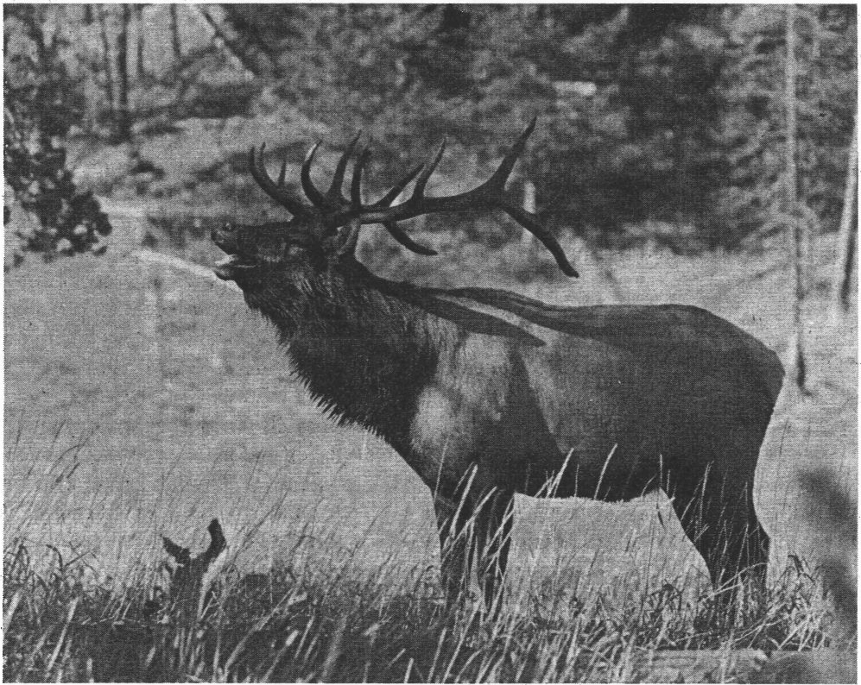

Elk in the Greater Yellowstone Area.

! Chapter 3: The Vision for Greater Yellowstone
1
Goal: Conserve the Sense of Naturalness and Maintain Ecosystem Integrity

  - 1
  - lI

i
'J
-.,,
I
I
'
'.:
I
I
I

I
J

--1

I
I
I

One of the many benefits of this variety is that across the GYA managers are provided with numerous "controls" by which to examine and evaluate their management. For example, just as the forest lands may provide hunters with many opportunities to take game animals, the parks provide managers with unharvested populations of many of the same animals; studies of those unharvested popula­ tions are often quite helpful in facilitating management of harvested ones, and vice-veisa.

Forest and park management will cooperate with other state, federal, and private entities. The states have responsibility for management of wildlife and fish outside of Yellowstone Park, and the State of Wyoming coopera­ tively manages wildlife and fish in Grand Teton Park. Forest and park .management will assure high quality, diverse fish and wildlife habitats.

Coordinating Criteria

The GYCC shall encourage coordination and communica­ tion between federal, state and local fish and wildlife staff and the scientific community to:

- Use the cooperative information system/database described on page 3-40 to share and coordinate management of wildlife in the GYA. The GYCC will ensure that necessary fish and wildlife-related research and monitoring is performed and adequately coordi­ nated.

- Use the biological diversity coordinating criteria to ensure that wildlife management directed at enhancing any species or group of species does not unacceptably affect other species of animals or plants.

- Cooperate with State wildlife agencies, other federal agencies, conservation districts, sportsmen's groups, livestock organizations, conservation groups, and private landowners to identify wildlife population objectives. Formally identify range needs of GYA ungulate populations, in order to maintain or rees­ tablish historic migration routes of native ungulates. Support continued acquisition of critical winter range lands by exploring alternative approaches including

outright purchase, conservation easements,etc. such as is underway on the northern Yellowstone winter range.

- Develop a GYA-wide agreement addressing the management of introduced species of fish and wildlife, to permit adequate coordination of such introductions, both past and future, in light of differing agency mandates.

- Continue to develop and initiate GYA-wide bison management coordination now underway, as well as research that will fill in existing information gaps on brucellosis in domestic livestock and wild animals. Ensure that all involved parties and agencies recognize that brucellosis is a critical concern and the rights of private landowners must be fully protected.

- Determine GYA-wide fishery data base needs, focusing on the ecological base that supports the fishery rather than only on individual fish species.

- Emphasize management for native fish in waters where good populations exist and manage to restore. native fish to their historic waters, especially in national park waters, where existing legislative mandates provide such direction. At the same time, recognize the presence of non-native but highly popular sport fish in many waters, especially outside national parks, as providing quality fisheries of substantial social and economic value. Non-native fisheries may be seen as providing the recreational variety appropriate within the multiple-use mandate of the national forests.

- Generally encourage management of all sport fish species under the wild trout concept, that is to avoid artificial manipulation of existing fish populations (through stocking, specifically). Wild, stream-bred sport fish provide the recreational experience, both for fishermen and for other users of aquatic resources, most appropriate in the GYA. Increase emphasis on providing opportunities for the physically challenged.

Vision for the Future
A Framework for Coordination rn the Greater Yellowstone Area

Chapter 3: The Vision for Greater Yellowstone
1
-l Goal: Conserve the Sense of Naturalness and Maintain Ecosystem Integrity

Wild trout management as a.general principle should not, however, prevent managers from managing specific waters (such as those unable to support spawning populations) in more manipulative ways.

i 9. The parks will continue implementation of the policy of no stocking of fish in parks, except where pre­ empted by legislation, or where such stocking pro­ tects rare or special interest species, or is part of a program designed to restore native fishes.

Vision for the Future
A Framework for Coordination in the Greater Yellowstone Area

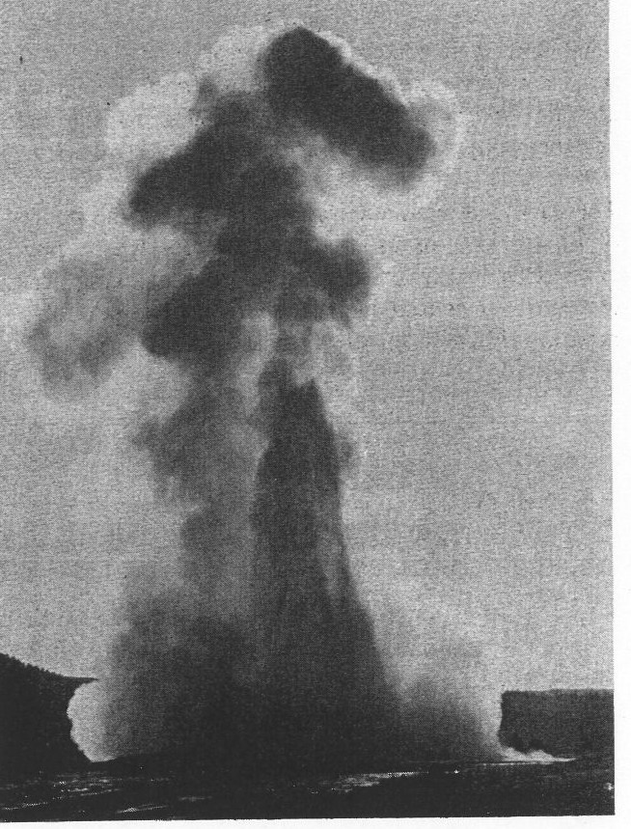
Goal: Conserve the Sense of Naturalne$S and Maintain Ecosystem Integrity
1

Ensure the Integrity of Geothermal
! Systems
.!
I
! Discussion

- .1
. ·.···1•
ij
-1
I
!
I

l

I
. I

,"-!
i'l
.·1
J

i

·:·j.J
One of the primary reasons for the establishment of Yellowstone National Park, and for its designations as a Biosphere Reserve and a World Heritage Site, was to protect its geothermal wonders. With more than 200 geysers and 10,000 hot pots, boiling springs, and other geothermal phenomena, Yellowstone encompasses the largest, most diverse intact display of these features to be found anywhere on the planet.

Geothermal energy-related development projects on adjoining forests will be thoroughly analyzed through the National Environmental Policy Act process and other studies. Projects permitted will have to be shown to be without potential to harm geothermal features. Researc to identify sensitive individual features, systems and their components, and the relationship of the geothermal features to surrounding lands and subsurface values mlL'\t proceed promptly in order to answer legitimate questions about where risks will not occur. In cases where current science and technology cannot provide adequate assurances, the activities will be disallowed.

Coordinating Criteria

The Forest Service and Park Service acknowledge that protection of the geothermal resources of the GYA is of paramount concern. Both agencies willexercise caution in management actions in the GYA so as not to damage _or destroy the geothermal features. As such, the agencies will:

- Emphasize, promote, and support research in the GYA to identify sensitive individual thermal features, systems, and their components, as well as the _relation­ ship of these geothermal features to surroundmg lands and hydrogeologic regimes. This will include concur­ rently advising appropriate committees of Congress of the funds necessary to perform the required research.

Old Faithful

- Ensure that management actions taken prior to completion of the research described in (1) above do not inadvertently d age ordestroy the geothermal features. The agencies will consult with each other prior to taking management actions that have the potential to damage these features:

- The Forest Service and Park Service will jointly develop guidelines to address exploration, leasing, and development of geothermal and oil and gas resources. The Bureau of Land Management (BLM) will be consulted in the development of these guidelines since the BLM has legal responsibility for downhole activi­ ties. By agreement with the Forest Service, the BLM also has responsibility for projecting reasonably foreseeable development scenarios on national forest system lands.

Vision for.the Future
A Fr mewo_rk fqr Coordin tion in the Greater YellowstQne Area

Chapter 3: The Vision for Greater Yellowstone r , . _. . ,' :
Goal: Conserve the Sense of Naturalness and .Maintain Ecosystem Integrity .

.·.l
:I

These guidelines will provide for·t he, prote<;tion -o f geothermal features until such time as the research described in (1) above is.completed. Theseguidelines will address the inconsistencies in the way oil and gas and geothermal leasiqg, exploration, and evelopment are .treated near sensitive geothermal areas. · These guidelines will ensure that ;tctivities will be disallowed in cases where current science and technology cannot provide adequate assurances that the geothermal resources will be protected.

- Identify significant surface therQl features outside Yellowstone .Park on ·federal Ian that should be
. protected be use of tb,eir ecological or. recreational values. As appropriate, recommend these areas as Research Natural Areas or Special lpterest Areas if features occur on forest lands. Further, the agencies will work with private landowners who are interested in better uiiderstanding and protecting·geothermal features that occur on their lands.·

- Provide for ineral e loration and development on National Fofest System. lands in those.ar eas where the geotherm al.features.inside.the park and t)le significant geothermal featµres outside the p;uk will not be adversely affected and where otherwise appropriate .

- T\ie Forest.Sc;ni ce· and Park Service ; will :work with sta e. and local· governm nts .to provide review of potential impactsto geothermal features for develop­ ments proposed on private lands, including applica-
. tions for.drilling :wells, tapp ing-spr ings, etc.

- Identify and correct areas where human activities, including vandalism, development design, or main­ tenance are or may have adverse effects on geother­ mal features.

' . , · · (

,:·-· ·

. '

. ' ·": ...

J •• 4 • ··,

.· •.. ·, :

• • •• f

. • ,:-·

Vision for;!he: F.uture
A Framework for Coordination injth e._Great r Yellowstone .Area

Goal: Conserve the Sense of Naturalness and Maintain Ecosystem Integrity

)
_ :-j

I
::j

'

Protect Wilderness Values and Resolve RemainingWildernessClassificationIssues In the GYA

Discussion

The GYA contains one of the largest remaining areas of wild land in the lower 48 states. There are few if any places in this country where visitors can enjoy such extensive vistas of undeveloped land, and can travel to such geographically remote areas. It is in good part because of the wild character of these lands that many of the other elements of the GYA, such as naturalness, diversity, and wildlife, can be guaranteed protection. Thus, even though these wilderness lands are themselves withdrawn from permanent settlement, their existence is essential to retaining the character of the rest of the GYA.

The Wilderness Act of 1964 focused public attention on the societal and intrinsic values of wilderness. It provided a mechanism for designation of wilderness areas that would: (1) perpetuate for present and future generations a long-lasting system of high quality wilderness that represents natural ecosystems; (2) provide opportunities for public use and enjoyment of the wilderness resource;
(3) allow plants and animals indigenous to the are.a to survive and develop through natural processes; (4) mam­ tain watersheds and airsheds in a healthy condition; (5) protect threatened or endangered plant and animal species; and (6) maintain the primitive cllar.acter of wilderness as a benchmark for ecological sturues. The mechanism provided by the Wilderness Act and sub­ sequent legislation has and willcontinue to serve the GYA well in maintaining the regional character of naturalness.

Coordinating Criteria

To protect wilderness resource values within the GYA:

- Through the Department of the Interior, the Park Service will continue to reco01mend to Congress that they formally designate as wilderness all park lands currently proposed for wilderness status. In the interim, the park will continue to manage proposed wilderness areas as though they were wilderness.

- The Forest Service and Park Service will cooperate in joint training of personnel in wilderness history and concepts, current resource management issues, wilder­ ness recreation management, and wilderness ad­ ministration.

- The agencies recognize that wilderness education is the most important tool for increasing public aware­ ness of wilderness values, for affecting attitude and behavior changes, and for developing an outdoor ethic. They will use the high visibility of the GYA to promote showcase management of wilderness by developing partnerships and challenge cost-share projects with user groups to teach wilderness ethics to their members and others.

- The agencies will complete planning for wilderness areas using the principles of limits of acceptable change (I.AC) and involving the public.

- The agencies will Jll:KSue more coordination in wilder­ ness management.

..
I
  - ..,;_
I

Vision for the Future
A Framework for Coordination in the Greater Yellowstone Area

I
Goal: Encourage Opportunities That Are Biologically and Economically Sustainable.

Provide for sustainable economic opportunities In the GYA through the balanced and environmentally sensitive use of resources such
-
I as oil and gas, timber, forage, and recreation. The development of
' showcase Industries in the GYA will not only maintain diversity and stability In the regional economy but will also establish the GYA as
a world class model of multiple use and preservation of a complex resource base.

Encourage and support opportunities for the agencies to work in partner­ ship with local communities. (Page 3-27)

Improve range conditions while pro­ viding sustainable economic oppor­ tunities for grazing and agriculture. (Page 3-28)

Provide opportunities for mineral, oil and gas, and sand, rock, and gravel development. (Page 3-29)

Provide opportunities for a variety of high-quality recreation experiences. (Page 3-31)

Provide opportunities for a sustain­ able timber industry. (Page- 3-35)

Chapter 3: The Vision for Greater Yellowstone
.;J Goal: Encourage Opportunities That Are Biologically and Economically Sustainable

The GYCC will Encourage and Support Opportunities for the Agencies to Work in Partnership with Local Communities

Community Partnership Opportunities
J

-1 The GYCC will:

- Provide information and help for communities in the GYA wishing to apply for grants in th Rural Economic Development Program. Support will be given to local communities that are considering the development of industries that can be sustained in the GYA through better utilization of raw materials extracted from the GYA, or by industries that can add further value to products already produced in the GYA.

- Encourage and support the private sector in eco­ nomical utilization of special features on private lands that enhance the recreation and general experiences of GYA visitors and residents. The agencies will

cooperate with private land owners, educational institutions, and historical societies in the development and protection of special resources on private lands, and will support the publication of materials that enhance recreation and educational values.

The Forest Service and Park Service will coordinate interpretive information of special features and resources on private lands with forest and park interpretive efforts, and provide assistance to local communities in training and developing the appro­ priate interpretation of the special features and resources.

The agencies will cooperate with the states, counties, and communities in assuring protection and develo p­ ment of these special features.

The GYCC will coordinate cooperative efforts be­ tween the federal agencies,the states, and the private sector to explore opportunities for tax incentives to facilitate the appropriate development and use of these special features on private lands.

INCOME annual income In millions of dollars
•
EMPLO'l'MENT

50 100 150 200 250

limber

r•na•

motorized recreation
!': nonmotorized
? recreation
.;
•
,j ' bill gam e

.e,
0
•
!
hunting
•mall game
hunting

flohlng akllng minerals

2 4 6 8 10

employment in thousands of person years*

*Oft• petaon yti•r repr•••ntl one
tull year of ftJll- ttm• empl oyment .
Figure 7. Income and Employment from Sources Directly Associated
with Forests and Parks (from 1987 Aggregation)

Goal: Encourage Opportunities That Are Biologically and Economically Sustainable

j
j I

:J:1

Improve Range Conditions While Providing Sustainable Economic Opportunities for Grazing and Agricutture

Discussion

More emphasis will be placed on managing the range resources from an ecological perspective and in maintain­ ing and improving range conditions, particularly riparian habitats. Responsible grazing of livestock on forest lands will continue where it is compatible with other GYA goals and values, and may be used for wildlife habitat improve­ ment and vegetative management.

Rural families and the farms and ranches they live on represent a cherished way of life. Wide-open spaces, hard work, and an affinity for the land and what it can produce serve as images of America for many people throughout
  - the world.

Livestock production and agriculture are important in­ dustries in the GYA, providingjobs for rural communities and contributing to the regional economy. The social and economic existence of many of the small towns in the GYA depends in part on livestock producers who operate on federal lands.

A healthy, economically viable livestock and agricultural industry is key to maintaining the valued rural appearance of the private lands in the GYA. These lands provide a pleasing transition as travelers approach the GYA parks and forests, and contribute to the general sense of natural­ ness. Grazing can affect ecosystem values, however, agricultural use of the GYA also can contribute to the overall naturalness of the area.

Coordinating Criteria

The Forest Service and Park Service will continue to:

I. Base management of range resources on sound ecological principles using up-to-date scientific know­ ledge and technology. Emphasis will be on integrating range management with other resource values, includ-

ing soil, water, wildlife, and visual effects, and on maintaining or improving riparian habitats.

- Accelerate preparation or updating of allotment management plans using resource-based capacities; continue to involve permittees and the public in their development.

- Aggressively and consistently administer and enforce allotment management plans.

- Identify and prioritize an updated inventory of poor condition range lands in need of restoration. Utilize public involvement in this process.

- Aggressively implement the interagency/interstate Memorandum of Understanding to control noxious weeds.

- Develop a long-term strategy to increase funding to meet needs for range management programs.

- Manage range lands in coordination and cooperation with adjacent lands of different ownership.

- The Park Service will examine grazing issues in Grand Teton Park. They will inventory and collect informa­ tion on allotments, analyze range conditions, address irrigation, and modify the range management plan as necessary to correct identified problems. The Park Service will recognize and consider valid grazing rights provided for in the establishment of the park. The long-term goal of tbe NPS is to eliminate grazing in Grand Teton Park.

- The Park Service will pursue implementation of NPS policies which state that backcountry grazing of out­ fitter, private and administrative stock in parks will be phased out. Pelletized, weed-free stock food will be required.

Provide Opportunities for Mineral, Oil and Gas, and Sand, Rock and Gravel Development

:d Discussion
·1
Mineral extraction activities were a part of the GYA prior to creation of Yellowstone Park. In the 1850s and l&iOs, prospectors wandered the region in search of gold, and by the late 1860s, the New World Mining District, in the general area of present Cooke City, Montana, was a thriving mining community.

Mineral exploration and development continues to be a valid use of national forests. Responsible mineral develop­ ment activities will continue on forest lands where it is compatible with other GYA goals and values.
Coordinating Criteria

The Forest Service and Park Service will emphasize cooperation between agencies with respect to mineral leasing and development activities in the GYA. As such, they will:

- Ensure consistency of minerals management between Forest Service regions in the GYA for similar types of activities by developing mineral guidelines for the GYA. As part of the regional guide process, the agencies will also develop criteria to ensure consistent operating and reclamation standards, and application of stipulations between forests, e.g., use of the no surface occupancy stipulations, containerized mud systems, directional-drilling techniques to avoid intru­ sions in scenic vistas, etc.

. 2. The Forest Service and Park Service will jointly

The Aggregation lists numerous minerals that were in the
analyze oil and gas and geothermal leasing and devel­

past, or are now present in various quantities, including
opment in the GYA..
Geothermal resources are

gold, nickeL chromium, talc, travertine, platinum-group metals, silver, copper, and lead. In the late 1800s and early 1900s, small coal mines were locally successful in some areas, including Yellowstone Park itself, where the
U.S. Army mined coal to heat Fort Yellowstone. Today there are approximately 11,800 mining claims in the forests of the GYA, about 30 percent of which have operations or are administratively current.

The overthrust belt, along the Idaho-Wyoming border, is the primary focus of interest for oil and gas development in the GYA. The most extensive exploration for oil and gas has occurred in the Bridger-Teton and Shoshone National Forests. About 60 percent of the lands in the GYA are withdrawn from mineral leasing and mineral entry. As of 1987, 17 percent of GYA lands were under lease for gas, oil, or phosphates, and another three percent had lease applications pending.

The GYA also contains a known geothermal resource area. Development and leasing has been suspended in order to complete research on the inter-connectedness of significant thermal features.
discussed in this document on page 3-22. The agen­ cies will invite other surface land managing agencies and interested industries and environmental groups to participate in the analysis. This will result in consis­ tent implementation of the new Forest Service oil and gas leasing regulations throughout the GYA. This analysis will: (a) inventory the oil, gas, and geother­ mal resources, and evaluate the development potential for these resources GYA-wide; (b) develop and consistently apply criteria, e.g., steep slopes, grizzly bear habitat, culturaL and historic sites, etc., which determine where leasing and development is and is not appropriate, based on protection of resource values within the GYA, and identify areas in the GYA where oil and gas and geothermal operations can or cannot be satisfactorily mitigated and therefore should or should not be permitted to occur; and (c) project potential oil, gas, and geothermal development scenar­ ios and address the cumulative impacts of these scenarios on the resources of the G YA.

., Goal: Encourage Opportunities That Are Biologically and Economically Sustainable
I
3. Ensure both agencies have an opportunity for timely review and comment on mineral plans of operations in the GYA, including but not limited to applications for permit to drill (APDs), exploratory and develop­ ment plans, and environmental analyses related to mineral exploration and developm ent within the G YA.
I

i
.1

  - .,1

I
:-J
71
- Use existing Memorandums of Understanding be­ tween the two agencies to facilitate sharing of services and expertise between the agencies.

- Inventory abandoned mineral sites in the GYA and jointly prioritize sites needing remedial action or reclamation. Work with appropriate states to obtain abandoned mine funds for reclamation of these sites.

- Inventory existing sand, rock, and gravel operations in the GYA, and develop a rock resource management plan for both active and abandoned operations. This plan should include: (a) limiting sand, rock, and gravel extraction in parks; and (b) reclaiming aban­ doned pits on both forests and parks. The agencies will look for opportunities to acquire sand, rock and gravel from commercial sources.

- The Forest Service and Park Service will ensure protection of geothermal resources throughout the GYA. Where such protection cannot be ensured through appropriate stipulations in leases or mineral operating plans, the agencies will recommend through the Bureau of Land Management that the Secretary of the Interior withdraw sensitive resource areas from mineral location and leasing, or where allowed, the agencies will acquire mineral rights.

I
I

Provide Opportunities for a Variety of High­ Quality Recreation Experiences

Discussion

Many neighboring communities and cities serve as hosts to the GYA. However, the hospitality system reaches far beyond the borders of the GYA, to include such major cities as Denver, Salt Lake City, and Billings. In these many communities, countless private businesses serve the needs of visitors to the GYA, as well as serving its resi­ dents.

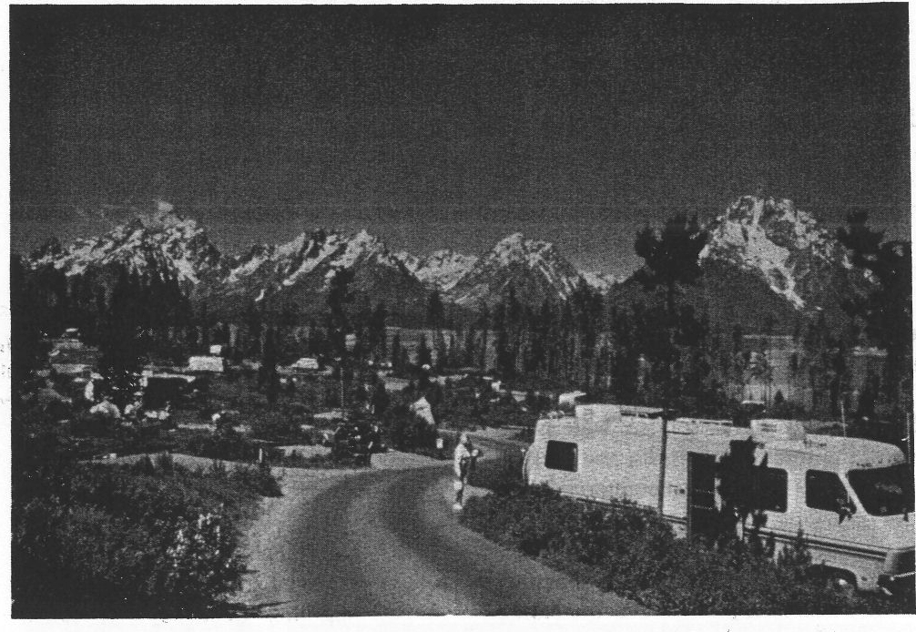
Responsibly managed recreation opportunities will continue in the GYA where they are compatible with other GYA goals and values. The partnerships on federal lands - the concessioners and permittees - continue their important services for the GYA visitors. An aura of "hospitality" reaches each visitor to the area, presenting the GYA as unique and belonging to them. Thus defined, the GYA experience is a broad one, involving not only the land itself but its distant travel connections, its local communities, and its residents.

Designated and recommended wilderness areas and other areas of wilderness character share the majority of the backcountry use in the GYA. Designated wilderness areas, and areas recommended as wilderness, are of special significance, managed for wilderness values. Primitive and back-country recreation opportunities also exist in other roadless areas with wilderness-like charac­ teristics that are managed with less rigid constraints than designated wilderness.

Hunting and fishing continue as an important recreation and economic activity in the GYA, with harvesting of a variety of big and small game species. Hunting has additional values in the GYA as both a wildlife manage ment and a wildlife control tool.

l
j

. . . I
camping in the Greater Yellowstone Area.

Goal: Encourage Opportunities That Are Biologically and Economically Sustainable

'::II

Coordinating Criteria

- The Forest Service and Park Service will plan and provide a variety of recreation opportunities, both motorized and non-motorized, based on the character of the resources and the needs of the visitors to the GYA. The agencies will jointly identify needs and rank sites for visitor facilities, e.g., campgrounds. Specifically, the agencies will:

  - Coordinate a GYA-wide recreation opportunity spectrum and user needs inventory for use in agency management of recreation programs. This will ensure that a variety of quality recreation experiences are available in environmental set­ ting.s that have acceptable physical, social, and managerial characterizations.

  - Develop a broad social study with priorities and monitoring strategies and techniques. This will provide a clearer understanding of sociological factors influencing visitation, and of visitor expec0 tations for the GYA. It also will provide for con­ tinual interaction with the visitors, surveying, monitoring, understanding, and providing mean­ ingful information to the GYCC that allows appropriate responsiveness to visitor needs.

  - In accordance with the agencies' missions and responsibilities,provide recreational opportunities that are appropriately distributed throughout the area considering the potential conflicts between different users and their activities, e.g., trail bikes vs. bad e-country hiking.

  - Recognize wildlife viewing as a highly popular and importan activity.

- The Forest Service and Park Service will assess backcountry use of the forests and parks, and seek an appropriate balance between the commercial and private use.

- The Forest Service and Park Service will maintain strong cooperative relationships with the recreation service partners (outfitter industry, guest ranches,

concessioners, etc.) operating in the GYA to meet the current and changing needs of recreatio nists.

A high degree of professionalism will be fostered and a quality outdoor experience will be provided. Activities will be conducted consistent with manage­ ment objectives. User conflicts will be minimized and reasonable opportunities will exist for both guided and nonguided recreationists to enjoy the recreation opportunities 9f the area.

In wilderness areas and the parks, emphasis will be placed on minimum-impact use and the outfitter will be a teacher or interpreter of these values, as well as a provider of equipment and services.

Policy for the authorization and administration of guided activities will be coordinated in the GYA and standardized to the greatest extent possible in the GYA amended outfitter policy.

- The Forest Service and Park Service will cooperate with the states, other federal agencies, and private landowners to e_nhance the spectrum of recreation opportunities. Further, the agencies will provide leadership and coordination in identifying opportuni­ ties for the private sector to provide quality recreation opportunities and services.

- The Forest Service and Park Service will ensure that recreation opportunities and activities do not adversely
-a ffect the overall values and qualities of the GYA. Specifically, they will:

  - Establish a system that determines baseline condi­ tions of the GYA backcountry, roadless, and wilderness areas, identifies potential impacts and changes, and manages use based on ffects to GYA values; Methods that may be used include cumulative effects models or limits of acceptable change (lAC) analyses. '

  - Coordinate recreation use to be sensitive to seasonal needs of wildlife resources, e.g., wildlife migrations, nesting, and bear food sources.

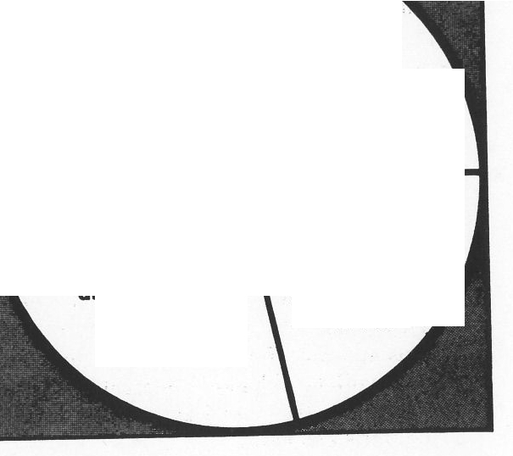
  - Enhance the compatibility of existing facilities with the overall values of the GYA.

wllderneH
32%
other forest & perk lands 24%
recommended wlldemeH & wllderneH
undeveloped study er•••
er••• 21%
23%

- The Forest Service and Park Service will cooperate with state and other federal agencies, private organiza­ tions, the private business sector, and private land­ owners, ensuring appropriate and coordinated access to and in the GYA. The agencies will:

  - Examine the potential for an enhanced system of transportation to and in the GYA, considering mass tr it.

  - Identify neces,sary access for recreation oppor­ tunities, such as stream access across private property and scenic rights-of-way, and acquire those rights by easement, land exchange, federal, state and private organization purchases or dona­ tions.

  - Improve the maintenance of forest and park roads and trails where needed and desirable.

- The Forest Service and Park Service will implement existing forest and park management plans that propose that large portions of the roadless and undeveloped areas outside of wilderness remain roadless. These roadless areas complement the existing wilderness areas by providing a variety of primitive and semiprimitive recreation opportunities.

Figure 8 illustrates the percent of forest and park
,; lands in various land classifications.
The analysis of various land classification reveals the following:

  - Uoder the 1964 Wilderness Act, only Congress can designate areas as wilderness. Congressional­ ly designated wilderness includes 32% of the lands in the GYA {3,786,500 acres) and is cur­ rently all within forests.

Figure 8. Land Classification in the GYA

  - Forest plans specify that approximately 2,073,000 acres that are currently undeveloped roadless will remain so. These lands comprise most of this category.

  - Another 2,449,600 acres (21%) have been recom­ mended for wilderness by Forest Service or Park Service. Other areas totalling 237,000 acres are wilderness study areas.

  - About 24% of the land area is generally accessi­ ble by forest or park roads. These roads provide access to a wide variety of recreation uses, graz­ ing, timber harvest acres, mineral and oil and gas activities, and areas where large numbers of visitors could not otherwise be accommodated.

In summary, approximately 70% of the forest and park lands are currently, and will continue to be, managed without roads and therefore in an undevel­ oped condition.

.·,'

i
I'
I
j
i
I

i
·1

Chapter 3: The Vision for Greater Yellowstone

Goal: Encourage Opportunities That Are Biologically and Economically Sustainable

- The agencies will address the issue of dispersal of recreation and economic opportunities in order to prevent concentrations of developments that serve the public, or a carnival atmosphere incompatible with GYA values. Recreational opportunities and special features are not just available in both national parks, but are available throughout the entire area.

  - The Forest Service and Park Service will support private endeavors outside of the forests and parks with coordinated recreation development and efforts, such as trails, interpretive programs, and GYA information and education publications. The GYCC will coordinate efforts to promote the use of private facilities and services in the GYA as a means of dispersing visitor use in the GYA by working with local communities to identify and advertise those services available outside of the forests and parks.

  - The Forest Service and Park Service will maintain recreation facilities that do not conflict with community developments and activities. Econom­ ic development that is compatible with the objec­ tives of the GYA will be encouraged outside the parks. This will be accomplished by identifying and maintaining a ceiling on the number of overnight sleeping spaces (pillow counts) in the parks, while concurrently exploring opportunities for tax incentives to encourage compatible eco­ nomic'development outside of the parks.

Vision for the Future

A Framework for Coordination in the Greater Yellowstone Area

i 3-34

Provide Opportunities for a Sustainable Timber Industry

Discussion

,j The timber industry has long been an important economic
! and social presence in the GYA. To many visitors and
residents, the logger or lumberjack is still a fi e of romance associated with frontier values and even wilder­ ness val es. The timber industry is an important force in shaping regional culture, and plays a significant role in land management besides its economic and social roles. Responsible timber harvesting will continue where it is compatible with other GYA goals and values.

Sixty percent of the GYA is forested; no other element of the GYA setting so dominates the landscape, or so often establishes the character of the GYA experience. Nineteen percent of GYA forested lands are considered suitable for timber harvest.

The forests of the GYA have experienced a variety of silvicultural practices in this century, and are capable of providing sustained timber harvests in the future. A stable, healthy timber industry can use the GYA as a showcase of its technology and contributions to the management of the forests. Limited new timber road construction can be expected in the GYA to reach re­ sources identified in forest plans. Timber roads no longer needed will be closed or reclaimed. Timber harvesting can be accomplished in such a way that it, and associated impacts of roads, will not disrupt the overall functioning of the ecosystem and natural appearance of the area. Timber harvesting is also instrumental as a tool to achieve other goals, such as managing biological diversity, wildlife, and recreation.

Coordinating Criteria

    - Timber management will be performed to meet land management objectives and in such a way as to provide for the integrity of the ecosystem and the natural appearance of the area.

The Forest Service will mtegrate the uses of forest resources while maintaining and enhancing ecological values such as biological diversity and sustained productivity. Landscape-level management strate es will be developed to maintain ecosystem values while yielding economic benefits. This ecosystem approach will reflect recognition of values and uses such as old-growth forests and other special ecological com­ munities, wildlife and fisheries habitat, air and water quality, aesthetics, and public attitudes about tradition­ al forest uses and products.

    - Management of timber will reflect the overall GYA goal to minimize both the total miles of roads and the miles of open roads. The impacts of constructed roads will be minimized in some cases by obliterating the road and reclaiming the land to a near natural condition; in other cases, by keeping the road and closing it to traffic. The following criteria will b used for coordinating the planning, use and reclamation of existing and proposed roads in the GYA:

      - The Forest Service will explore and develop technology to minimize the total miles of new roads associated with timber harvest.

      - The Forest Service will explore incentives to encourage industry to develop and explore new technology that will reduce the amount of roads necessary.

      - Managers will strongly consider reclaiming roads constructed for timber harvest if future activities are not planned in the next ten years.

      - Unless there are other resource reasons for a road constructed for timber harvest to remain open, the road will be closed.

    - The Forest Service will identify and rank research and development needs relating to the growing, harvesting, milling, use, and marketing of timber. As a result of these agency efforts, the identification of new products (such as house trusses, girders, fuel pellets for wood stoves) that can be manufactured from milled timber and its by-products (boards, studs, bark dust, saw dust,

' Chapter 3: The Vision for Greater Yellowstone
Goal: Encourage Opportunities That Are Biologically and Economically Sustainable

chips) as well as the identification of markets for these
i new products, will help local communities develop a more sustainable timber economy while preserving the
.j ecological integrity of the GYA.
I
    - The GYCC will initiate a coordinated and integrated vegetation inventory.

Vision for the Future
A Framework for Coordination in the Greater Yellowstone Area

Goal: Improve Coordination.

Improve coordination and other administrative machinery to facili­ tate interagency cooperation in the GYA, and establish adequate information and educational systems to support protection of ecosystem values and socioeconomic resources.

Improve mechanisms to cooperate and coordinate with federal agencies, state and local governments, private landowners and GYA users. (Page 3- 39)

Promote research and education. (Page 3-42)

--!

Improve Mechanisms to Cooperate and Coordinate with Federal Agencies, State and Local Governments, Private Landowners, and GYA Users

Coordinating Criteria

- Organization

  - The GYCC will continue to provide management guidance in the GYA and will meet at least semi­ annually to review planning and management. The GYCC will establish a procedure to monitor and facilitate the interpretation and implementation of the coordinating criteria of this document.

  - In addition to research teams or other working groups referenced in other coordinating criteria, the GYCC will convene groups as necessary to address specific key research and resource issues, share information and expertise, resolve problems, and coordinate programs to meet management
needs.

  - Forests and parks will continue to share research and other resource-related positions, such as the existing soil scientist position shared between the Gallatin National Forest, Yellowstone National Park, and Grand Teton National Park. These shared positions will foster the exchange of "state of the art" technology and information across administrative boundaries.

- Operating Procedures

  - Implementing and updating the Vision will occur as follows:

    - Both agencies will develop a timetable and priorities to accomplish these goals, and will identify where funding increases or shifts are needed.
Funding proposals for implementing this Vision will be jointly developed and pursued through existing budget processes.

- The Vision will be reviewed and updated, if
needed, in ten year cycles.

- A progress report on all issues will be published every five years, with a short "bulletin" report every year on major accomplishments. Specific attention will be given to updating resource data bases as necessary throughout the GYA.

Full funding of park and forest plans is needed, as are funds to implement the level of coordination required in this Vision until updates of individual unit management plans can incorporate these costs.

  - Common management terminology will be developed between the Forest Service and Park Service, to facilitate all aspects of planning and coordination.

  - Existing cooperative management plans, agreements, and related management programs, will continue as viable means of communications, shared information, and coordinated management. They will provide the foundation and the thrust for future coordinated planning and management, addressing a broad spectrum of human needs and resource protection in the GYA.

- Planning

  - The GYCC will encourage coordinated resource management planning to resolve complex land-use issues, and to accomplish the coordinating criteria in the Vision. Coordinated resource management plans will be developed with the involvement of local communities and private and public organizations, e.g., conservation groups,

conservation districts, state fish and wildlife agencies, sportsmen's groups, and other appropriate parties, to best meet the needs and responsibilities of the landowners or public agencies involved.

  - Forests and parks will use the GYA Interagency Fire Management Planning and Coordination Guide to implement coordinated fire suppression and prescribed fire programs.

- Emergency Response

  - The GYCC will initiate the development of emergency operation plans that identify processes, procedures, organization, standards, and qualifications necessary to manage all potential emergency situations in the various jurisdictions of the GYA, using the existing Incident Command System as appropriate.

  - The Forest Service and Park Service will develop cooperative management plans,"memorandums of understanding", contracts, and permits with other agencies and the private sector to ensure preparedness for floods, earthquakes, fires, search and rescue, law enforcement situations, hazardous material spills, wildlife hazards and depredation, and other emergency situations.

  - The Forest Service, Park Service, states, and counties will develop an emergency operations networking radio system capable of addressing all emergency requirements in the GYA.

- Research

  - The GYCC will establish a mechanism to coordinate all research efforts on key issues in the GYA. This coordination will integrate research efforts with federal and state agencies to facilitate, rank, and track proposals and programs, and to provide a process for review and sharing of data.

  - The Forest Service and Park Service will jointly develop priorities for GYA research, and
integrate them into local forest and park plans, as appropriate .

  - The Forest Service and Park Service will continue coordinated and integrated research to share data, especially on topics that cross jurisdictional lines. This will prevent the duplication of research efforts. Research may span the jurisdictions of several responsible agencies and private lands.

- Information Management

  - The Forest Service and Park Service will recognize the ecological interrelationships in the GYA through an ecosystem approach to natural-resource management. Activities will be assessed in the context of the GYA setting. Research to improve understanding of ecosystem dynamics will continue, and Park Service and Forest Service resource professionals will share information.

  - Individual decisions made on one forest or park often have impacts on other units and may have impacts on the values of the GYA as a whole. To expand the cooperative relationship and ecosystem approach in managing millions of acres of forest and park lands, an information management system will be established and used for area-wide issues. Important technological issues will need to be addressed by the agencies. This information is vital in gaining public understanding of how both agencies are managing the GYA and it will be available to the public.

  - GYA-wide data collection standar.ds will be adopted and the Forest Service and Park Service will use shared data bases to perform needed cumulative effects analyses. The agencies will develop an "early warning system" that provides managers with information crucial to analyzing impacts on the ecosystem.

- Transportation

  - The goal throughout the GYA will be to minimiz.e both the total miles of roads and the miles of open roads. The impacts of constructed roads will be minimiz.ed in some cases by obliterating the road and reclaiming the land to a near natural condition; in other cases, by keeping the road and closing it to traffic. The following criteria will be used for coordinating the planning, use and reclamation of existing and proposed roads in the GYA:

- In implementing existing forest plans, managers will seek opportunities to balance new construction and road closures in such a way as to cause no net increase in open roads. There will be no net increase in roads inside park units.

- Managers will evaluate all existing roads and will reclaim any roads not necessary to meet the management objectives in their respective forest plans.

- Every five years, the GYCC will review the need, occurrence, and effectiveness of reclamation and access closures, and the status of roads in the GYA.

  - Utiliz.e the present Greater Yellowstone Cooperative Regional Transportation Study in compliance with the GYCC Vision goals to provide information to implement the following:

- Develop a coordinated transportation system to relieve congestion in high-use areas or at peak-use times. Consider mass-transit opportunities to reduce traffic in problem areas.

- Where appropriate, encourage visitors to the GYA to travel to or through areas that are currently under used in the GYA. Identify alternate access routes that have scenic qualities. In the neighboring states, officially
designate qualifying highways as "scenic byways•. Similarly, identify trails that have special recreational or scenic values and can divert traffic from more congested or environmentally sensitive trails.

- Work with the Federal Aviation Administration, the military, and private and commercial charters to develop an air management plan for GYA. The plan will address control of low level flights, and elimination of flights over sensitive areas, as well as how to mitigate impacts from aircraft over flights, including disruption of visitor experiences, effects on wildlife, noise intrusion, etc.

- Provide reasonable, environmentally sound, and efficient networks of transportation through the GYA for various forms of transportation, including i.e., bicycles, recreational vehicles, snowmobiles, passenger vehicles, foot,etc. Acquire "rights-of-way" that complete or facilitate these transportation networks.

- Provide corridors for utilities and sites for communication equipment compatible with the goals of the GYA.

- Communications

  - Improve communications methods between federal, state, and county agencies, and the private landowners of the GYA by standardizing and linking computer systems, and employing compatible field radio systems. Develop a GYA-wide agency directory (including all government offices, whether federal, state,. or local), an interagency newsletter, and other communications systems as seem appropriate.

Promote Research and Education

Discussion

Hundreds of researchers from dozens of disciplines and specialties work in the GYA every year, and produce a flood of important findings. Under the approaches proposed in thisVision, more research will be needed, and there will be even more reason to attract the very best researchers available.

As research findings become available and complement existing knowledge, there will be at least two levels to the educational process that must follow. The first involves education about the extraordinary collection of natural and cultural resources present in the GYA. The second involves education about the implementation of the combined Vision of the many groups and agencies involved in its future. A commitment to managing every acre of the GYA at its best, and making it a world model of unified, progressive management, requires a commitment to explaining that goal to the public. Public consciousness--local,regional, and national--of the values and significance of the GYA will be raised.

Coordinating Criteria

- The Forest Service and Park Service will foster and support expanded research programs in all fields related to GYA management.

In order to assume a leadership role in regional planning and management, the GYA must continue to attract leaders in such research. Natural resource research must increase, but there is an even greater need for expansion of research in sociological, cultural, and economic topics. There is likewise need for heightened cooperation in research between agencies.

A practical example of interagency coordination involves the creation of a system of key areas, representing significant or special habitats to better monitor ecosystem processes. Such study areas occurring on the national forests will be designated research natural areas. This system will build upon
already existing study sites and designs, such as long standing study areas on the northern range in Yellowstone Park.

- The Forest Service and Park Service will heighten public awareness of research findings so that existing research and new research become a part of the public awareness information base. The GYCC will expand on existing efforts to catalog all research findings applicable to the GYA.

Extensive agency research already completed in many fields is for the most part not the reaching public as it should be. Most citizens of the GYA would be surprised to learn that Yellowstone Park alone hosts more than 280 research projects, across the range of many disciplines, each year, and that the vast majority of those are conducted by non-agency personnel. Cooperation between the researchers, the agencies, and the many other research-sponsoring institutions and organizations can lead to far more consistent distribution and interpretation of research findings.

- Agency interpretive programs will be expanded and intensified, with greater emphasis on ecosystem-scale interpretation. This includes the following:

  - Threshold visitor centers will be developed, either in existing facilities or in new buildings, on the edge of the GYA along each major travel route. The visitor centers will be jointly sponsored and managed, and will interpret the special features of that particular travel corridor and the significance of the GYA.

  - Build upon the example of Yellowstone Park's environmental education program to create a coordinated, GYA-wide program with public schools. Foster innovative teacher -training and involvement programs both regionally and nationally.

  - Highlight the natural and cultural resources of the forests' interpretive programs, so that these resources are brought to the attention of the public to a similar extent as park resources.

Opportunities for such interpretation are boundless, and include cooperative programs with ranch, timber, mining, and other commercial interests besides the nature-oriented programs traditionally associated with such lands.

  - Develop and implement consistent sigrung throughout the GYA. Visitors to this area should immediately know upon entering any of the individual units of the GYA that they are entering a part of a much larger area recognized for its unique values. Signing might include the use of a unique GYA logo that would promote the shared roles of the agencies, while retaining for the public a distinction of the various agency facilities and areas.

- The agencies will ensure that GYA cooperating association programs, which are badly fragmented, are better coordinated.

These non-profit educational adjuncts of the agencies have an important role to play in the development and promotion of education. The cooperating association(s) should handle the many educational opportunities available, and to serve the distinct but overlapping needs of all parks and forests. There will be a single coordinating body that serves as a consistent and active link between all associations. If a specific national forest is unable to maintain a cooperating association of its own, one of the larger associations will welcome it into their program.

- The agencies will develop cooperative publication programs, enlisting the professional guidance of the cooperating associations.

Virtually every topic of significance in the GYA suffers because the public has not been adequately introduced to its complexities and intricacies. Books, films, and a variety of other materials are needed to introduce the public and agency personnel to GYA topics. A G YA map for the general visitor is of highest priority. There is immediate need for a GYA directory that will improve access to all agency, municipality, and organization personnel. The
Conservation Directory, published by the National Wildlife Federation, may serve as a good model. In many cases, the regional university community could play an important role in publication programs, as could private publishers.

- The agencies will jointly seek ways to increase national awareness of the GYA; emphasize its role as a modei providing a full variety of land uses across the spectrum of opportunities. These ways will include the hosting of land-use conferences in the GYA in cooperation with states, universities, and other interested parties.

- The agencies willexpand human resource programs to include more opportunities for special public involvement, such as volunteer programs for retired persons. In many cases this can be built on existing programs, such as the Student Conservation Association, or other independent, federal, state, or municipal programs.

- The agencies will develop a comprehensive interagency traimng team to acquaint agency personnel with GYA issues and perspectives and to promote understanding and implementation of the Vision.

- Develop a cross-training course on Forest Service and Park Service missions, traditions, and history for agency employees.

- The Forest Service and Park Service public information offices will foster improved communications among interest groups with different viewpoints in order to build relationships and trust in the agencies, and to gain acceptance of this GYA Vision by the interest groups.

Chapter 4: Summary

This document charts a new future for the Greater Yellowstone Area. While honoring their traditional legislative mandates and principles, the Forest Service and the Park Service will coordinate and communicate to an extent not previously experienced in the long history of the two agencies. The goals and coordinating criteria set forth in this Vision utilize legal mandates, agency expertise, and a wide variety of public involvement processes to accomplish the protection of this internationally recognized and cherished area.

The Vision recognizes the extraordinary values of this region, but does not limit its definition of those values to ecological characteristics and processes. The Vision recognizes that the worth of this unique ecosystem is, after al based on human value judgments, and that the agencies charged with protecting Greater Yellowstone are doing so to satisfy the wishes of human society.

The Vision, therefore, does not define resource protection and resource use as being mutually exclusive. Instead it introduces principles and processes that will help ensure that no matter what the resource use--be it the recreational needs of an individual, protection of biological diversity for the greater good of human society, or timber harvest for national and international markets--ecosystem values are considered first in how the resource is used. The Vision further recognizes that maintenance of ecosystem values can only be accomplished through research, education, and cooperation, and it is based on the conviction that these three activities are the best, most constructive avenues for reducing conflicts in the Greater Yellowstone Area.

Three fundamental philosophies are set forth in this document. They are:

- Conserve the sense of naturalness and maintain ecosystem integrity.

- Encourage opportunities that are biologically and economically sustainable.
- Use coordination and education to protect ecosystem values.

In many instances, the coordinating criteria in the Vision clearly represent new ways of doing business, not only between the two agencies, but also between the agencies and their many . constituencies, contractors, and concessioners. The central element of the shift is toward ecosystem management, but achieving that major shift will require many minor operational shifts. At the same time, the Forest Service and Park Service will not abandon their separate and often quite distinct mandates.

The Vision is not a document whose promise can be kept without serious commitment of resources, funds, and public support. Current forest and park plans and budgets do not reflect the costs and staffing needed to accomplish the visions contained in this document. Hence implementation may not occur at a pace that satisfies the public or the agencies themselves.

That does not in any way make this an unrealistic document. The Vision is, in fact, an answer to public and Congressional concern. In recent years, public comment and Congressional emphasis, as manifested in such events as the 1985 oversight hearings, have sent a clear message to Forest Service and Park Service Managers in the Greater Yellowstone Area. That message's foremost theme has been: "Protect this unique resource, and work together to do so." The Vision represents the agencies' response to that message. With the input and active involvement of the many Greater Yellowstone Area constituencies, the agencies have produced this document to provide the basic principles behind a host of specific management issues and challenges.

But the Vision only says what needs to be done, and how it is to be accomplished, in order to protect Greater Yellowstone. It does not, nor was it intended to, address issues of funding. It should be clear, however, that the public and Congress want protection and management to occur, not merely to be planned. The Vision could not have been produced without public support, and its goals

Chapter 4: Conclusion

cannot be achieved without such support. Greater Yellowstone is priceless, but it is not without cost.

This V,sion statement is a major step in land management, but it is hardly a departure from the American land management tradition. It is, in fact, just a continuation of the conservation tradition that began in this same ecosystem when the first national park and the first national forest were created here. The pioneering spirit that led to the development of those institutions has led us to respecting their resources on a grander scale. Just as the world looked to America for leadership in the national park and national forest movements, they now look here for leadership and inspiration in addressing such global issues as biological diversity and the ecological health of the entire planet.

No place in North America, perhaps no place on earth, is a more fitting site to pioneer ecosystem management. The Greater Yellowstone Area has the public and legislative support, the agency enthusiasm, and the unparalleled natural resource, to provide a world class model of such management. It is an opportunity the Forest Service and Park Service have wholeheartedly embraced.

Vision for the Future
A Framework for Coordination in the Greater Yellowstone Area

4-2

Chapter 5: What Comes Next

TheVision's basic purpose is to focus both agencies during the management plan and regional guide review process, and to provide a common focus for the individual park and forest plans. As such, it provides the overall view of the GYA, how the cumulative effects of agency plans on regionwide resources are considered, and the structure to resolve inconsistencies that may occur.

The Vision is not a regional plan. It is a statement of principles. It does not make specific land allocation decisions, and does not seek to change the separate missions of the national forests or the national parks. Management principles suggested in the Vision can be accomplished within the existing legal framework, and without either agency going outside of its historic and legal mandates.

The final step in the coordination process is the completion of whatever amendments may be needed to Forest Service regional guides and forest plans and to the parks' statements for management, general management plans, and resource management plans. Using the principles provided by the Vision as guidance, managers will create amendments that display a consistent approach to describe management prescriptions, that contain management standards and guidelines, and that incorporate existing coordinating guideline documents for specific management programs in the GYA.

These amendments, and those that follow whenever forest and park plans are revised, will be documented under the provisions of the National Environmental Policy Act. Thus, actual decision-making will occur under existing authorities and processes that govern each forest and park and at the time the amendments are considered.

Glossary of Terms
Aggregation of Park and Forest Plans or •Aggregation• - A document that outlines the extent of resources, human uses and management activities and plans in the GYA as of 1987 and displays the effects of implementing park and forest plans.

Alrshed - Geographic area that, because of topography, meteorology, and climate shares the same air. As applied by the Clean Air Act, amended August 1977, the term covers all Wildernesses larger than 5,000 acres that were in existence as of August 1977.

Airshed Classes

Class I - International parks; national wilderness areas which exceed 5,000 acres in size; national memorial parks which exceed 5,000 acres in size; national parks which exceed 6,000 acres in size, and which were in existence in August 1977; and other areas designated by Congress after passage of the Clean Air Act as Class I status. Class I designation ensures the highest level of protection of air quality related values, or stated differently, Class I areas are permitted the smallest amount of deterioration under the Act.

Class II - All areas of the country not designated as Class I. More deterioration of air quality is permitted in Class II areas than in Class I areas.

Class III - Areas of least desirable air quality. There are presently no Class III areas designated in the U.S.

Amenity Values - Typically used to describe resource properties for which market values are not or cannot be established.

Big Game Winter Range - Area available to and used by big game through the winter seaso n.

Biological Diversity - The distribution and abundance of plant and animal communities and species within an area and the processes by which these species came to inhabit the area.

Change on the Range - An effort throughout the Forest Service to reemphasize management of range resources from an ecological and vegetation management perspective. Change on the Range offers a vision of high quality rangelands with healthy vegetation that supports livestock, protects soil and water, provides riparian and upland habitat for fish and wildlife, produces economic benefits to communities, and meets public desires for open space.

Commodity Values - Those which can be traded in the market place.

Consumptive Use - Use of resources that reduces the supply, such as logging and mining. Refer also to nonconsumptive
use.

Cultural Resource - Remains of sites, structures, or objects used by humans in the past, either historic or prehistoric.

Cultural Resource Management (CRM) - Management of resources relating to past human life. This includes buildings, sites, areas, architecture, memorials, and objects having scientific, historic or social values.

Vision for the Future
A Framework for Coordination in the Greater Yellowstone Area

Cumulative Effects Analysis - A methodology to assess the effects that a series of actions may have on the sensitive resources of an area. Used, for example, in evaluating impacts on grizzly, bald eagles, and riparian areas.

Cumulative Effects Assessment - Procedure to evaluate combined effects on sensitive resources resulting from multiple land uses over space and time. ·

Cumulative Impacts - The impact on the environment which results from the incremental impact of the action when added to other past, present, and reasonably foreseeable future actions, regardless of what agency (federal or nonfederal) or person undertakes such actions. Cumulative impacts can result from individually minor, but collectively significant actions taking place over a period of time. (40 CFR 1508.7)

Desired Future Condition - A future land or resource condition that achieves a set of resource goals and objectives.

Ecosystem - Living organisms (biotic) together with their nonliving environment (abiotic) forming an interacting system inhabiting a defined area of interest. There is not an obvious boundary to separate an individual ecosystem from it surroundings. Scientists have used the term to refer to systems as small as an individual pond, and as large as the planet.

Ecosystem Condition - The state of various parts of an ecosystem. For a component such as a wildlife population, it might be measured in terms of numbers or population structure; for vegetation, it might be measured in terms of species composition, cover or growth; for visitors, it might be measured in terms of preference or satisfaction.

Ecosystem Management- In the broadest sense, managing the ecosystem (area) to achieve the desired future conditions. As used in this Vision, the central theme means to view an ecosystem as a whole and maintain its changing interactive processes as opposed to focusing on a specific resource of interest such as timber harvest or big game harvest without also considering the inputs these activities might have on other components of the ecosystem.

Endangered Species - Any species of animal or plant that is in danger of extinction throughout all or a significant portion of its range . A plant or animal species identified by the Secretary of the Interior as endangered in accordance with the 1973 Endangered Species Act.

Fire

Prescribed Fire - Wildland fire burning under specified (prescribed) conditions which will accomplish certain planned objectives. The fire may result from planned or unplanned ignitions. Fires which burn outside the specified conditions are considered escaped fires.

Wildfire - Any wildland fire that is not a prescribed fire, including escaped fires.

Forage - All browse and nonwoody plants that are available to wildlife for grazing, or harvested for feeding.

Forest Supervisor - Official responsible for administering National Forest System lands in a Forest Service administrative unit which may consist of two or more National Forests. Forest Supervisors report to the Regional Forester. Forests are further divided into Ranger Districts.

General Management Plan - A NPS planning document that sets forth the basic management philosophy for a park, zones the park according to sensitive resources and permissible uses, and provides the overall strategies for addressin_g issues and achieving identified management objectives.

Vision for the Future
A Framework for Coordination in the Greater Yellowstone Area

Goal - The desired end result.

Guideline - A set of land, resource, or human use values or parameters meant to generally guide organizational actions.

Habitat - Place where a plant or animal naturally or normally lives or grows.

Instream Flow - Prescribed level (or levels) of streamflow, usually expressed as a stipulation in a permit authorizing a dam or water diversion for the purpose of meeting management objectives.

Integrated Pest Management (IPM) - Process for selecting strategies to regulate pests in which all aspects of a pest-ho st system are studied and weighed. The information considered in selecting appropriate strategies includes the impact of the unregulated population on various resource values, alternative regulation tactics and strategies, and cost/benefit estimates of those alternative strategies. Regulatory strategies are based on ecology of the pest-host system and consist of a combination of tactics that may include selective use of pesticides, mechanical controls, and biological agents.

Interdisciplinary Approach (IDTeam) - Utilization of one or more individuals representing areas of knowledge and skills focusing on the same task, problem, or subject. Team member interaction provides necessary insight to all stages of the process.

Umits of Acceptable Change (LAC) System - A management-by-objectives planning system that involves establishing minimally acceptable resource and social conditions, and monitoring to make certain those conditions, at least, are being achieved. IAC has historically been focused primarily on recreation management, and usually involves extensive public involvement.

Local Dependent Industries - Industries relying on forest or park outputs and programs for economic activity. Mineral Entry - Filing of a mining claim for public lands to obtain the right to any minerals it may contain. Mineral Exploration - Search for valuable minerals on lands open to mineral entry.
Mineral Production - Extraction of mineral deposits.

Mineral Withdrawal - Public lands withdrawn from entry under the general mining laws and/or withdrawn from availability under the mineral leasing laws. ·

Minerals, Common Variety - Deposits which, although they may have value for use in trade, manufacture, the sciences, or in the mechanical or ornamental arts, do not possess a distinct special economic value for such use over and above the normal uses of the general sum of such deposits. May include sand, stone, grave pumicite, cinders, pumice (except that occurring in pieces over two inches on a side), clay, and petrified wood. Common variety minerals are not available for disposal on NPS lands.

Minerals, Leasable - Coal, oil, gas, phosphate, sodium, potassium, oil shale, sulphur, and geothermal steam. Neither Yellowstone Park nor Grand Teton park are open for mineral leasing.

Minerals, Locatable - Those hardrock minerals which are mined and processed for the recovery of the minerals, often metallic. They generally fall under the purview of the General Mining Law of 1872. Both Yellowstone Park and Grand Teton Park were closed to mineral entry at the time the parks were established.

Vision for the Future
A Framework for Coordination In the Greater Yellowstone Area

Mitigation - Actions to avoid, minimize, reduce, eliminate or rectify the impact of a management practice.

Monitoring and Evaluation - Monitoring and evaluation is the periodic evaluation of the condition, or health, of sensitive resources. It also may include the periodic evaluation on a sample basis of forest and park management practices to determine how well objectives have been met, and how closely management standards have been applied.

Motorized Travel - Travel using an engine or motor.

Multiple Use - Management of all the various renewable surface resources of the National Forest System so that they are utilized in the combination that will best meet the needs of the American people; making the most judicious use of the land for some or all of these resources or related services over areas large enough to provide sufficient latitude for periodic adjustments in use to conform to changing needs and conditions; that some lands will be used for less than all of the resources available; and harmonious and coordinated management of the various resources, each with the other, without impairment of the productivity of the land, with consideration being given to the relative values of the various resources, and not necessarily the combination of uses that will give the greatest dollar return or the greatest unit output.

National Environmental Policy Act (NEPA) - Act passed in 1970 which purposes were: to declare a national policy which will encourage productive and enjoyable harmony between man and his environment; to promote efforts which will prevent or eliminate damage to the environment and biosphere and stimulate the health and welfare of man, to enrich the understanding of the ecological systems and natural resources important to the nation; and to establish the Council on Environmental Quality.

New Perspectives - A Forest Service program to enhance awareness, understanding, and commitment to managing the national forests and national grasslands for their full array of values and benefits, especially their ecological sustainability and long-term productivity. The goal is to develop and demonstrate socially acceptable, scientifically sound ways to manage lands and resources to meet people's needs for forest and rangeland products while protecting natural and cultural resources for the long-term health of the land and quality of life. New Perspectives responds to new scientific knowledge, new management and research plans, and new expectations of the American people for the uses, health, and diversity of their National Forest System.

Non-Consumptive Use - Use of a resource that does not reduce the supply. For example, nonconsumptive uses of water include boating, swimming and fishing.

Noxious Weeds - Plant species that are undesirable, that is, species that conflict, restrict, or otherwise cause problems with management objectives.

Old Growth - Old growth forests are ecosystems distinguished by old trees and related structural attributes. Old growth encompasses the later stages of timber stand development that typically differ from earlier stages in a variety of characteristics. These may include tree size, accumulations of large dead woody material, number of canopy layers, species composition, and ecosystem function.

Outfitter - Concessionaire - Individual or company providing equipment, supplies, livestock or materials for services to the public, such as rental of boats, skis, horses or tents; or conducting of guided trips for education, hunting, float boating, ski touring, helicopter skiing, snowmobiling, jeep tours, fishing, lodging, food and other retail services. These are managed through specific government regulated licenses, permits, and contracts.

Vision for the Future
A Framework for Coordination In the Greater Yellowstone Area

Park Superintendent - Official responsible for administering National Park System lands in an administrative unit, e.g., a national park, national monument, or national recreation area. Park Superintendents usually report to the NPS Regional Director.

Public Issues - Subject or question of widespread public interest relating to management of forests or parks.

Public ParticlpaUon - Meetings, conferences seminars, workshops, tours, written comments, responses to survey questionnaires, and similar activities designed and held to obtain comments from the public about Forest Service and Park Service planning.

Recreation Opportunity Spectrum (ROS) - Recreation resource delineations which identify a variety of recreation experience opportunities along a continuum from primitive to urban. Each class is defined in terms of natural resource settings, activities which occur within it, and experience opportunities available.

Regional Director - Official responsible for administering a single region of the National Park Service. There are ten regions in the National Park Service.

Regional Forester - Official responsible for administering a single region of the U.S. Forest Service. There are nine regions in the U.S. Forest Service.

Regional Guide - Forest Service planning guidelines which guide all natural resource management activities and establish management standards and guidelines for the National Forest·System lands of a given region.

Riparian - Areas of land that are directly influenced by water. They usually have visible vegetative or physical characteristics reflecting this water influence. Stream sides, lake borders, or marshes are typical riparian areas.

Roadless (Undeveloped) Areas - National forest areas larger than 5,000 acres, or smaller areas that are contiguous to designated wilderness or primitive areas, which contain no roads and have been inventoried by the Forest Service for possible inclusion in the wilderness system. Roadless areas as referenced in this document are limited to those areas that are identified as roadless in the forest plans.

Statement for Management - NPS management document that defines the purpose and significance of a park, identifies the major issues, and establishes management objectives.

Sense of Naturalness - As used in this document it is that state in which landscapes appear and ecological processes
- operate, much as they would without the effects of modern man, even though man and his activities occur. Man's activities are carried out so that they harmonize with, rather than intrude upon the landscape.

State Air Quality Regulations - Legal base for control of air pollution sources in a particular state. Prescribed burning is generally covered under these regulations.

Stipulation - Conditions of a lease agreement, or conditions of an approval for a proposed action. Stipulations are generally identified to protect sensitive resources, e.g., by restricting activities by time of year, size, etc.

Sustainable - An activity or resource use that will ensure the continuation of that use in perpetuity without impairment of that resource or ecosystem values.

Vision for the Future
A Framework for Coordination in the Greater Yellowstone Area

Threatened Species - Those plant or animal species likely to become endangered species throughout all or a significant portion of their range within the foreseeable future. Those plant or animal species identified by the Secretary of Interior as threatened in accordance with the 1973 Endangered Species Act.

Transportation System - Network of facilities that includes all existing and planned roads, trails, and other transportation­ related designated facilities. Those designated facilities include parking lots, highways, over-snow travelways, yarding systems, tramways, trailheads, boat ramps, and heliports.

Visual Resource - Composite of basic terrain, geologic features, water features, vegetative patterns, and land uses that
typify a land unit and influence the aesthetic appeal the area may have for visitors.

Wild River - Wild and Scenic Rivers Act usage. Those rivers or sections of rivers that are free of impoundments and generally inaccessible except by trail, with watersheds or shorelines essentially primitive and unpolluted.

Wilderness - Area designated by Congressional action under the 1964 Wilderness Act. Wilderness is defined as an area where the earth and its community of life are untrammeled by man, where man himself is a visitor who does not remain. Further, wilderness is an area of undeveloped federal land retaining is primeval character and influence without permanent improvements or human habitation. Wilderness areas are protected and managed to preserve their natural conditions, which generally appear to have been affected primarily by the forces of nature, with imprint of man's activity substantially unnoticeable; have outstanding opportunities for solitude or a primitive and unconfined type of recreation; include at least 5,000 acres, or is of sufficient size to make practical their preservation, enjoyment, and use in an unimpaired condition; and may contain features of scientific, educational, scenic, or historic value as well as ecologic and geologic interest.

Vision for the Future
A Framework for Coordination in the Greater Yellowstone Area

Appendix A: Memorandum of Understanding

APPENDIX A

MEMORANDUM OF UNDERSTANDING

between

The Rocky Mountain Region NATIONAL PARK SERVICE
and

The Northern, Rocky Mountain, and lntermountain Regions

FOREST SERVICE

In recognition of the Agencies' tradition of public service and responsible land management, to assure the perpetuation and enhancement of integrated resource management, and to affirm the intent to continue to serve the public interest
through mutual cooperation and coordination, th.e Rocky Mountain Region of the National Park Service and the
Northern, Rocky Mountain, and Intermountain Regions of the Forest Service enter jointly into this agreement. The agreement affirms support of the 1964 Memorandum of Understanding and the December 16, 1985, letter endorsed by the Director of the National Park Service and the Chief of the Forest Service. It is also a document to facilitate subsequent agreements among field units of both Agencies.

As steps toward meeting the intent of the Memorandum of Understanding and to provide better service to the public, we agree to work together to:

  - Capitalize on the differences in mission and authorities between the two Agencies to achieve in combinat ion a higher level of public service than could be obtained separately.

  - Reinforce existing coordination mechanisms, which are the Greater Yellowstone Coordinating Committee (GYCC) and the Interagency Grizzly Bear Committee (IGBC); and to develop new methods when necessary.

  - Encourage cooperation at the field level of both Agencies.

  - Identify, evaluate, and consult on issues and on potentially conflicting policies, while retaining Agency decision authorities.

  - Discuss issues and if possible resolve disagreements within the Agencies, refraining from prematurely and/ or unilaterally exciting public controversy.

  - Jointly develop research and monitoring procedures on activities that could affect common goals.

  - Encourage field units to develop and implement cooperative projects and studies designed to achieve co mmon goals.

Vision for the Future
A Framework for Coordination in the Greater Yellowstone Area

A-1

  - Develop a joint strategy for public information and education throughout the Regions.

  - Encourage joint public and interagency participation activities on shared issues.

  - Coordinate planning and land management strategies within applicable statutes.

  - Conduct periodic evaluations of plans and policies to promote consistency and to avoid unexplainable differences.

  - Coordinate schedules for development, update, and maintenance of appropriate management plans.

  - Develop and implement techniques to improve compatibility of data bases and information systems.

  - Encourage the exchange of employees among agencies for conferences, agency meetings, details, or longer term assignments.
We agree that progress on the items identified in this memorandum will be among the subjects of an annual meeting of the Regional Director of the Park Service and the three Regional Foresters. Other issues or new items may be added as a result of the meeting.
This memorandum will become effective as soon as it is signed by all parties and will continue until terminated by any party after 30 days notice in writing to the others of the intention to end this memorandum.

/s/ Jack Neckels 9/24/86 /s/ Gary E. Cargill 9/24/86

Acting Regional Director Rocky Mountain Region USDI, National Park Service
Regional Forester
Rocky Mountain Region
USDA, Forest Service

/s/ J.S. Tixier 9/24/86 /s/ James C. Overbay 9/24/86

Regional Forester Intermountain Region USDA, Forest Service
Regional Forester Northern Region USDA, Forest Service

Vision for the Future
A Framework for Coordination in the Greater Yellowstone Area

A-2

APPENDIX B

Key Legislation Pertaining to Management of National Forests and National Parks

Listed below are the key Legislation and Executive Orders that provide guidance for management of National Forests and National Parks.

Airport and Airway Development Act of 1970, PL 91-258, 49 USC 1716

American Folklife Preservation Act of 1976, PL 94-201, 89 Stat. 1130, 20 USC 2101-2107 American Indian Religious Freedom Act, PL 95-341; 42 USC 1996
An Act to Improve the Administration of the National Park System, 16 USC la7 Anadromous Fish Conservation Act, 16 USC 757a
Analysis of Impacts of Prime or Unique Agricultural Lands iri Implementing the National Environmental Policy Act,
ES 80-3, 8/11/80, 45 FR 59109

Antiquities Act of 1906, PL 59-209, 34 Stat. 225, 16 USC 432 Archeological and Historic Preservation Act of 1974, PL 93-291
Archeological Resources Protection Act, PL %-95, 93 Stat. 712, 16 USC 470aa et seq. Architectural Barriers Act of 1%8, PL 90-480, 82 Stat. 718, 42 USC 4151 et seq.
Bald and Golden Eagle Protection Act, 16 USC 668

Clarke-McNary Act of 1924, Ch. 2, 30 Stat. 11, as amended; 16 USC 473 et seq. Clean Air Act, as amended; PL 88-206, 42 USC 7401 et seq.
Coastal Zone Management Act of 1972, PL 92-583, 16 USC 1451 et seq.

Concessions Policy Act of 1%5, PL 89-249, 16 USC 20 et seq.

Department of Transportation Act of 1%6, PL 89-670, 49 USC 1651 et seq. Disposal of Materials on Public Lands, 30 USC 601-604
Endangered Species Act of 1973, as amended; PL 93-205, 87 Stat. 884, 16 USC 1531 et seq.

Vision for the Future
A Framework for Coordination in the Greater Yellowstone Area

B-1

Energy Supply and Environmental Coordination Act of 1974, PL 93-319, 42 USC 1857-1 et seq. Estuary Protection Act, PL 90-454, 16 USC 1221

Executive Order 11593:

Executive Order 11870:

Executive Order 11987:

Executive Order 11988:

Executive Order 11990:

Executive Order 11989:

Executive Order 11991:

Executive Order 12003:

Executive Order 12088:

Executive Order 12372:
Protection and Enhancement of the Cultural Environment, 36 FR 8921

Environmental Safeguards on Activities for Animal Damage Control on Federal Lands, 40 FR 30611

Exotic Organisms, 42 FR 26407

Floodplain Management, 42 FR 26951, 3 CFR 121 (Supp 177)

Protection of Wetlands, 42 FR 26961, 3 CFR 121 (Supp 177) Off-road Vehicles on Public Lands, 42 FR 26959 and 11644 Protection and Enhancement of Environmental Quality
Energy Policy and Conservation, 3 CFR 134 (Supp 1977), 42 USC 2601 Federal Compliance with Pollution Control Standards Intergovernmental Review of Federal Programs, 47 FR 30959

Federal Environmental Pesticide Control Act of 1972, PL 92-516, 7 USC 135 et seq.

Federal Land Policy and Management Act of 1976, PL 94-579, 90 Stat. 2743, as amended; 43 USC 1701 et seq. Federal Powers Act, 16 USC 823a
Federal Water Pollution Control Act (commonly referred to as the Clean Water Act), PL 92-500, 33 USC 9 1251
et seq.

Federal Water Project Recreation Act, 16 USC 4601-12 to 4601-21

Fish and Wildlife Coordination Act, as amemded; PL 85-624, 16 USC 661 et seq. Forest Highways Act of 1958, PL 85-767, 72 Stat. 885, 23 USC 201 et seq.
Forest and Rangeland Renewable Resources Planning Act of 1974, PL 93-378, 88 Stat. 476, as amended; 16 USC 1601
et seq.

Forest and Rangeland Renewable Resources Research Act of 1978, PL 95-307, 92 Stat. 353, as amended; 16 USC 1600 et seq.
Freedom of Information Act, PL 93-502, 5 USC 552 et seq.

General Authorities Act of 1970, as amended; PL 94-458, 16 USC lal et seq. Geothermal Steam Act of 1970, 30 USC 1001-1025
Granger-Thye Act of 1950, Ch. 97, 64 Stat. 82, 16 USC 490 et seq.

Historic Preservation Act of 1966, PL 89-665, 80 Stat. 915, 16 USC et seq.

Historic Sites Act, 44 Stat. 666, 16 USC 461-462

Interagency Consultation to Avoid or Mitigate Adverse Effects on Rivers in the Nationwide Inventory, 45 FR 59189, 8/15/80, E.S. 80-2

Intergovernmental Coordination Act of 1969, 42 USC 4101, 4231, and 4233

Intergovernmental Cooperation Act of 1968, PL 90-577, 40 USC 4201

Knutson-Vandenberg Act of 1930, Ch. 416, 46 Stat. 527, as amended; 16 USC 576-576b Land and Water Conservation Fund Act of 1965, PL 88-578, 16 USC 460 1-8(f) Marine Mammal Protection Act, PL 92-552, 16 USC 1361 et seq.
Marine Protection, Research, and Sanctuaries Act of 1972, PL 92-532, 16 USC 1361 et seq. Mining Act of 1872, 30 USC 22
Mining Activity Within National Park Service Areas, PL 94-429, 16 USC 1901 et seq. Multiple-Use Sustained Yield Act of 1960, PL 86-517, 74 Stat. 215, 16 USC 528 et seq.
National Environmental Policy Act of 1969, PL 91-190, 42 USC 4321 et seq.

National Forest Management Act of 1976, PL 94-588, 90 Stat. 249, as amended ; 16 USC 472a et seq. National Historic Preservation Act, PL 89-565, 80 Stat. 915, 16 USC 470 et seq.
National Park System Final Procedures for Implementing EO 11988 and 11990 (45 FR 35916 as revised by 47 FR 36718) National Trails System Act, PL 90-543, 16 USC 1241 to 1249
National Trust Act of 1949, PL 81-408, 63 Stat. 927

Noise Control Act of 1972, as amended; PL 92-574, 42 USC 4901 et seq. Occupancy Permits Act of 1915, Ch. 144, 38 Stat. 1086, as amended; 16 USC 497

Vision for the Future
A Framework for Coordination in the Greater Yellowstone Area

8 -3

Appendix B: Key Legislation Pertaining to Management of National Forests and National Parks

Organic Administration Act of 1897, Ch. 2, 30 Stat. 11, as amended; 16 USC 473 et seq. Outer Continental Shelf Lands Act, 43 USC 1331-1356
Payment in Lieu of Taxes Act, PL 94-565, 31 USC 1601 et seq.

Protection of Historic and Cultural Properties, 36 CFR Part 800, 44 FR 6068

Public Buildings Cooperative Use Act of 1976, PL 94-541, 90 Stat. 2505

Public Rangelands Improvement Act of 1978, PL 95-514, 92 Stat . 1806, 43 USC 1752 et seq.
Rehabilitation Act of 1973, PL 93-112, 87 Stat. 357, 'l9 USC 701 et seq. as amended by the Rehabilitation Act Admendments of 1974, 88 Stat. 1617

Reservoir Salvage Act of 1960, PL 67-523, 74 Stat. 220, 16 USC 469-469c Resource Conservation and Recovery Act, PL 94-580, 52 USC 6901 Safe Drinking Water Act, PL 93-523, 42 USC 300f et seq.
Sisk Act of 1967, PL 90-171, 81 Stat. 531, as amended; 16 USC 484a

Small Tracts Act of 1983, PL 97-465, 96 Stat. 2535, 16 USC 521c-521i Surface Mining Control and Reclamation Act, PL 95-87, 30 USC 1201
Surface Transportation Assistance Act of 1982, 96 Stat. 2097, 15 USC 713c-3, et seq.

The Act of August 25, 1916, National Park Sevice Organic Act, PL 64-235, 16 USC 1, 2-4, as amended

Toxic Substances Control Act, PL 94-469, 15 USC 2601

Twenty-five Percent Fund Act of 1908, Ch. 192, 35 Stat. 251, as amended; 16 USC 500, 16 USC 553, 31 USC 534 Uniform Relocation Assistance and Real Property Acquisition Policies Act of 1970, PL 91-646, 42 USC 4651 et seq. Watershed Protection and Flood Prevention Act, 16 USC 1001, 68 Stat. 666, PL 92-419, 86 Stat. 667
Water Resources Planning Act of 1965, PL 89-80, 42 U.S.C. 1962 et seq., and Water Resource Council's Principles and Standards, 44 FR 723977

Weeks Law Act of 1911, Ch. 186, 36 Stat. 961, as amended; 16 USC 480 et seq.

Wilderness Act of 1964, PL 88-577, 16 USC 1311 et seq.

Appendix C: GYA Coordination Documents and Projects

APPENDIX C

GYA Coordination Documents and Projects

Preparing "The Aggregation of National Park and National Forest Management Plans" for the GYA, the first report of its kind.

Developing guidelines for managing grizzly bear in the Greater Yellowstone Area .

Cooperating in law enforcement and prosecution for violations of federal regulations in parks and forests. Coordinating information and education efforts to raise public awareness of grizzly bear management efforts.
Developing and maintaining the GYA outfitter and guide policy establishing guidelines for dealing with outfitters, guides, and organized activities.

Studying elk management to establish and maintain healthy elk populations in the Greater Yellowstone Area .

Developing the Greater Yellowstone Regional Cooperative Transportation Study, which examined the regional transportation system.

Supporting development and implementation of a model to measure cumulative effects of land uses and activities. Such a model will help in managing grizzly bear habitat.

Providing managerial nucleus and logistical and personnel support to the Interagency Grizzly Bear Subcommittee for the Greater Yellowstone Area .

Supporting GYA cooperative groups such as the Greater Yellowstone Bald Eagle Working Team. The document "A Bald Eagle Management Plan for the Greater Yellowstone Ecosystem" was published in 1983 by the Wyoming Game and Fish Department.

Developing the "GYA Interagency Fire Management Planning and Coordination Guide" published in June 1990.

Developed "Guidelines for Coordinated Management of Noxious Weeds in the GYA" in cooperation with the Bureau of Land Management, and the States of Wyoming, Montana, and Idaho. Scheduled for publication in September 1990.

Coordination of "Scenic Byway" designation and management across regional and agency boundaries. Supporting management efforts to expand populations of trumpeter swans in the Greater Yellowstone Area .

J} U.S.GOVERNMENT PRINTING OFFICE: 1990 • 573-764

Vision for the Future
A Framework for Coordination in the Greater Yellowstone Area

C-1

NPS 0-357

* U.S. Government Printing Office: 1991- ( Jacket- No. 574-150)

